**AWS-VPC :**

**concepts**

**1.Vpc**

**2.Nat gateway providing internt to the private instanccee**

**3.vpc peering 🡪connection b/w two netwokrs**

**4. VPC NACL 🡪more security level**

**5.VPC endpoint 🡪without having internet access to your private instance ,you can access your aws services**

**6.vpc flowlogs**

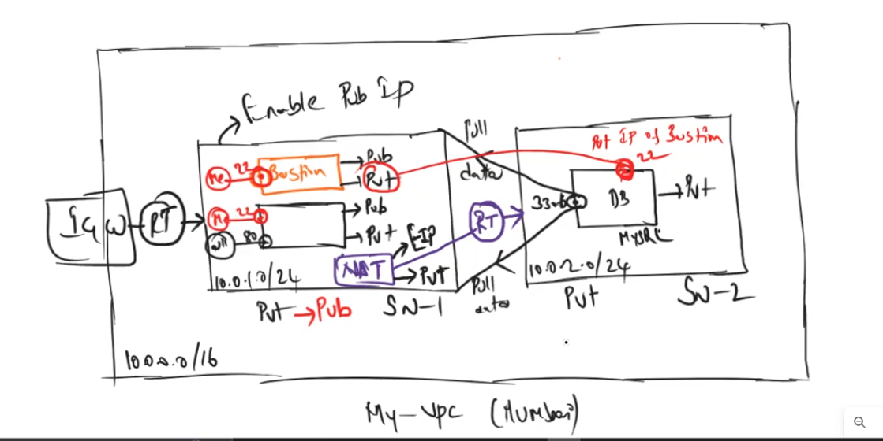

**Or**

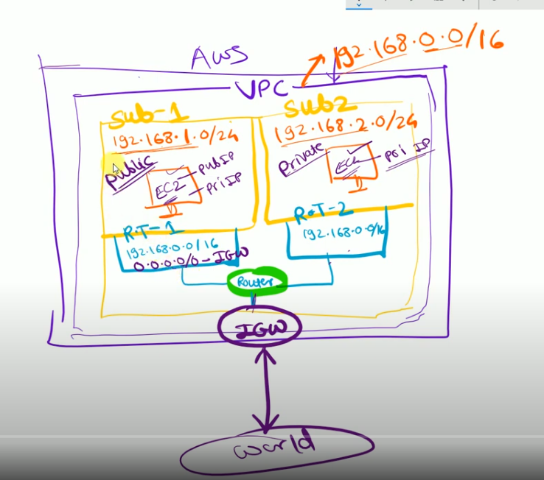

1.Vpc creations 192.168.0.0/16

2.Two subnets

One subnet will be associate with one availability zone . one availbilty zone can associated with multiple subnets

Public Subnet 1 : 192.168.1.0/24 ap-south-1a(Mumbai) private subnet 2 : 192.168.2.0/24 ap-south-1b

When create subnet bothe subnets are private ..You make it has a public

3.Internet gate way

**Every vcp required internet gateway .every vpc have one internet gateway and attach to the vpc**

4. two Route table :

Note : One vpc always configuring one route table by default

You required two route tables

Default Route table consider as RT-1

Create route table 2 RT-2

Route table 1 associate with public subnet -1 Route table 2 associate with private subnet2

Which make it as public subnet attached to the route table that Route you can attach to the internet gateway

Vpc creations 192.168.0.0/16

How to create a vpc ?

1.go to aws dashboard

2.search service vpc

3.clikc on vpc

4.clikc on your vpc

5.click create vpc

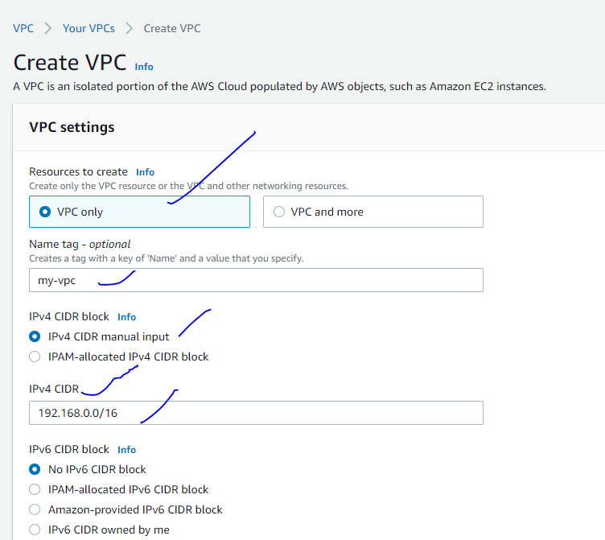

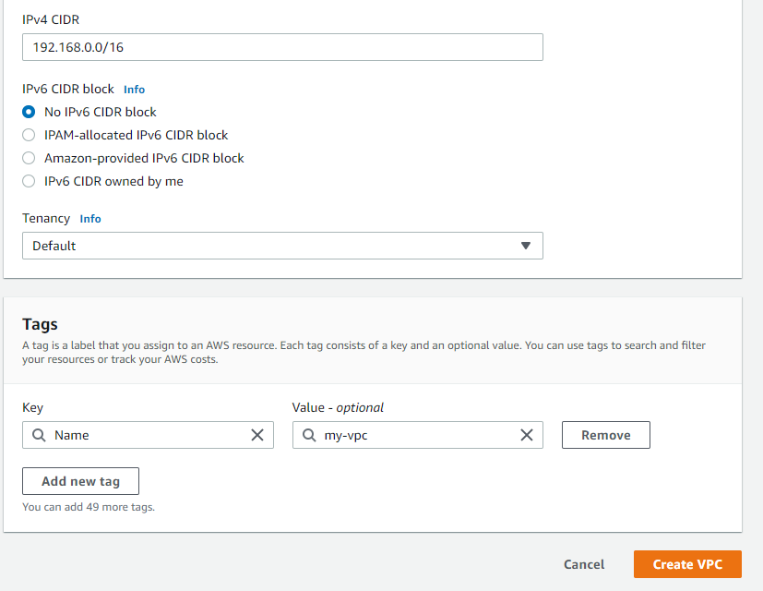

6.click on create vpc

Step2 : how create a subnets ?

Two subnets

**Note :One subnet will be associate with one availability zone . one availbilty zone can associated with multiple subnets

Public Subnet 1 : 192.168.1.0/24 ap-south-1a(Mumbai) private subnet 2 : 192.168.2.0/24 ap-south-1b

When create subnet bothe subnets are private ..You make it has a public

1.click on subnets

2.clikc on create subnets

3.select your vpc

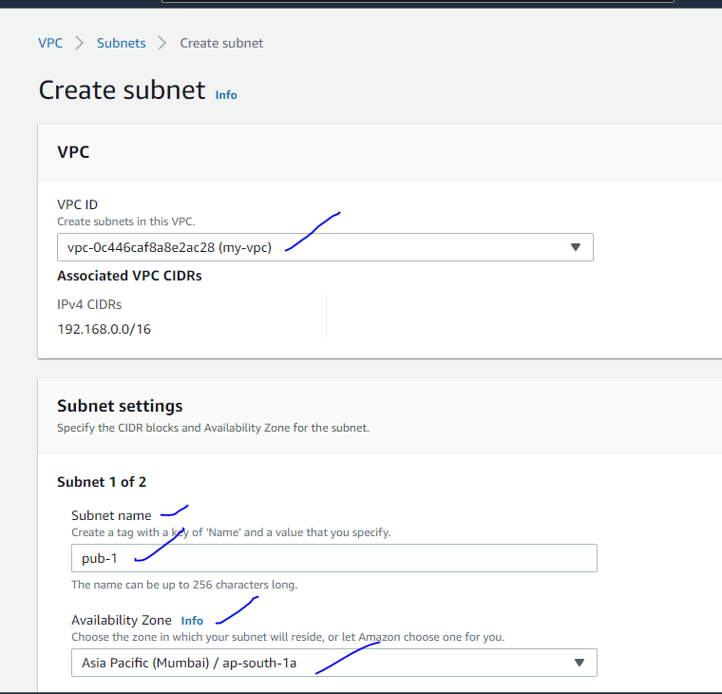

Subnet 1- public

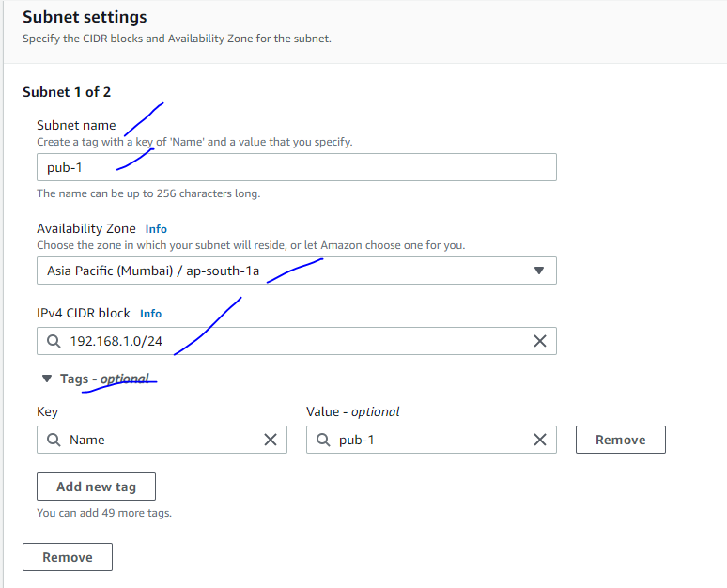

Subnet 2 : private

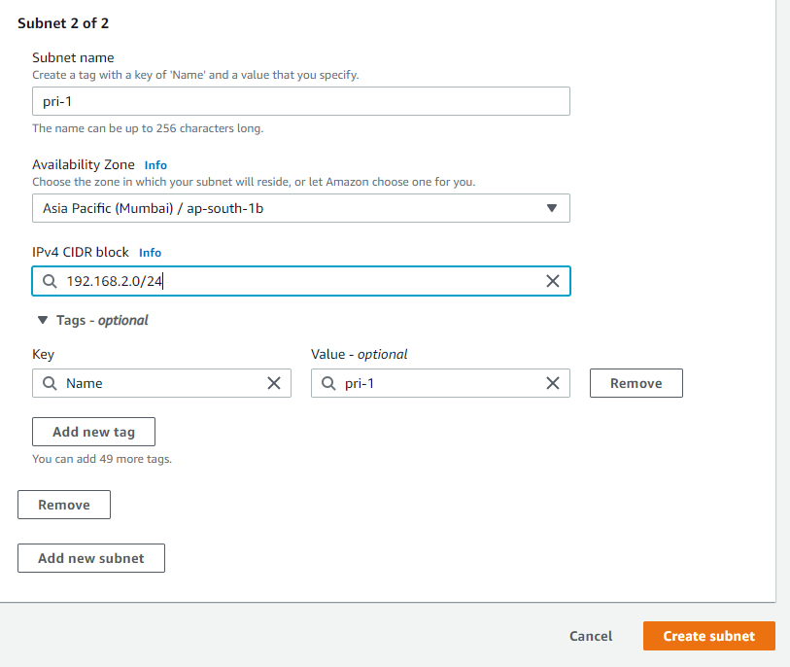

**Which one you want to public subnet enable auto assign public mention to the subnet

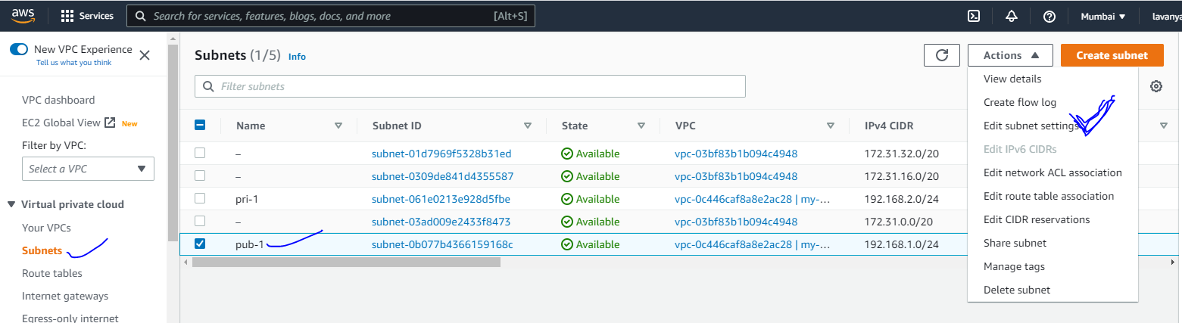

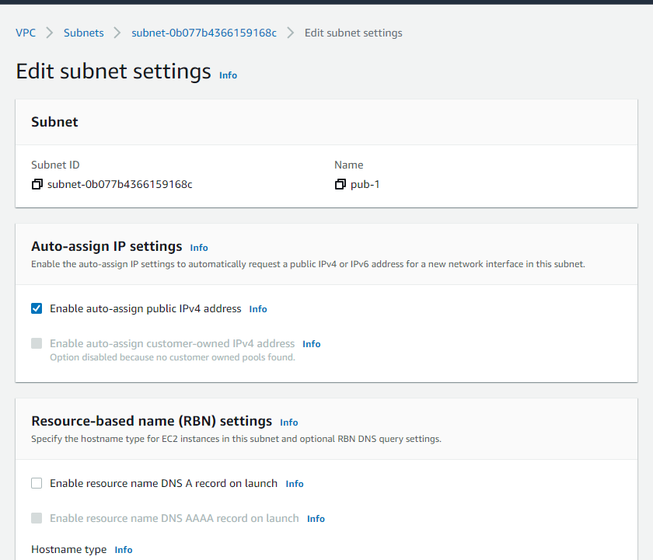

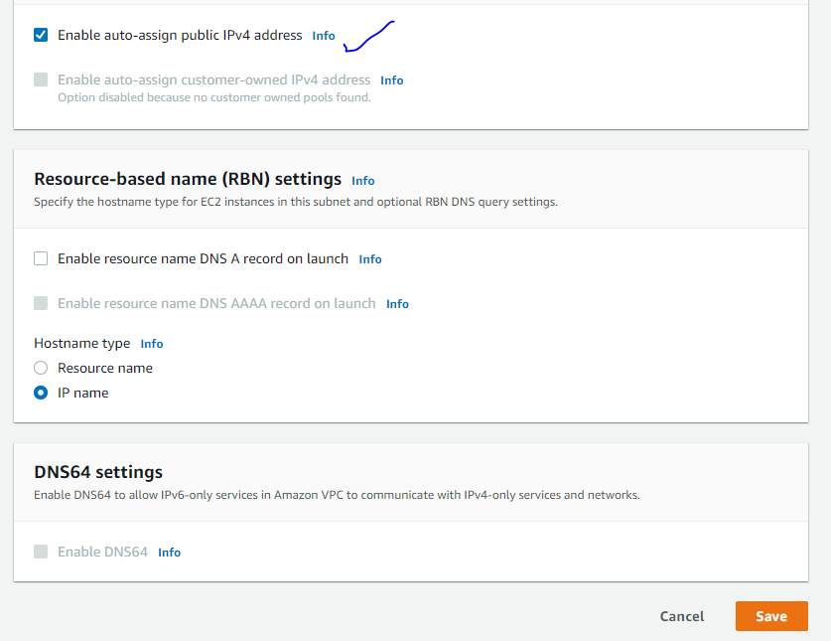

Step 3: IGW

Create Internet Gate way

Internet gate way

**Every vcp required internet gateway .every vpc have one internet gateway and attach to the vpc**

1.clikc on internet gate way

2.click on create internet gateway

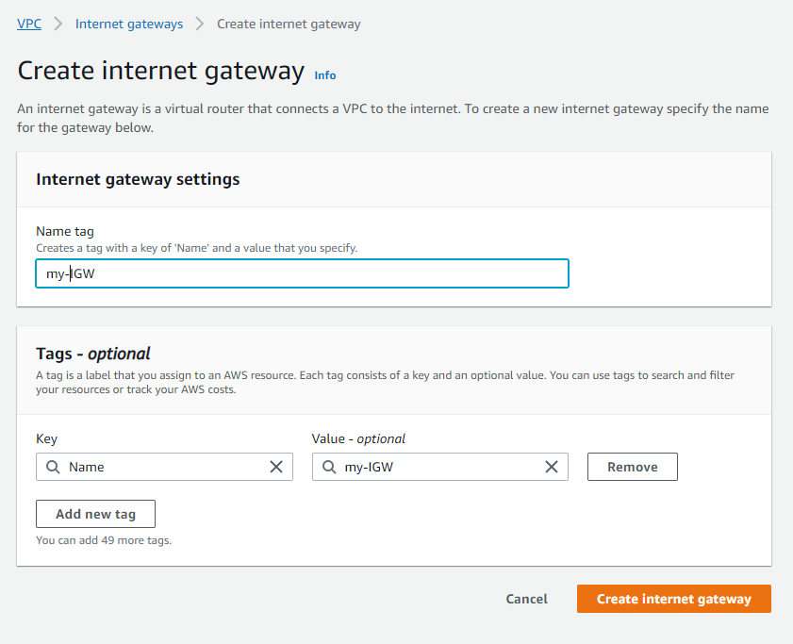

3.clikc on create internet gate way

Step 3 : attach vpc to internet gate way

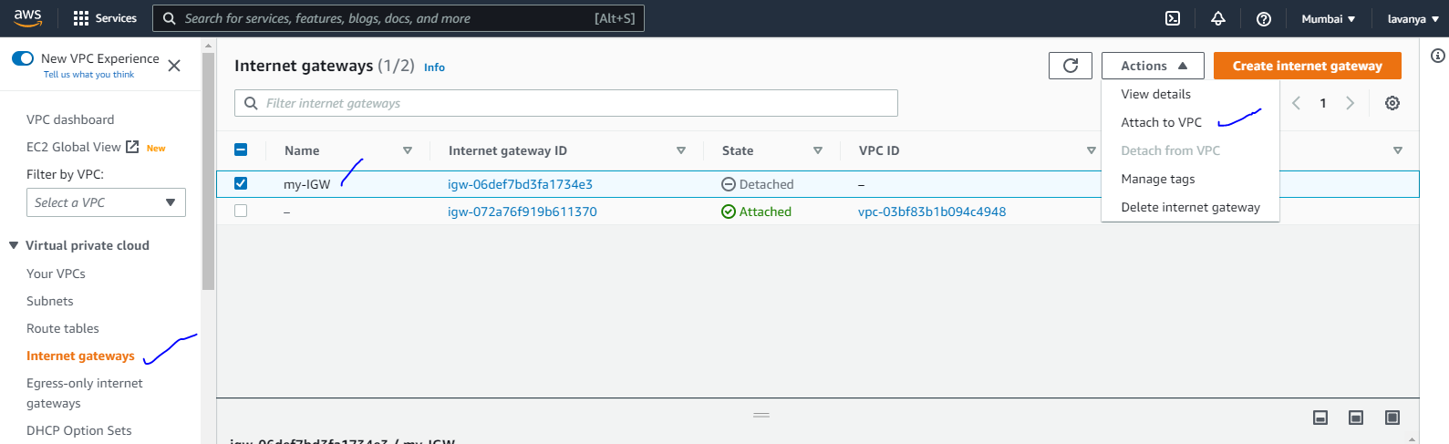

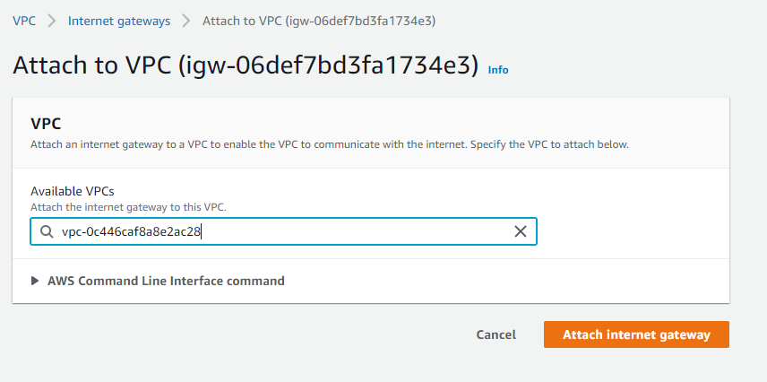

Step4 : create a routetable

**When you create vpc along with one route table is created .You mention has private Route table

Create public route table

1.click on create route table

2.enter the fileds

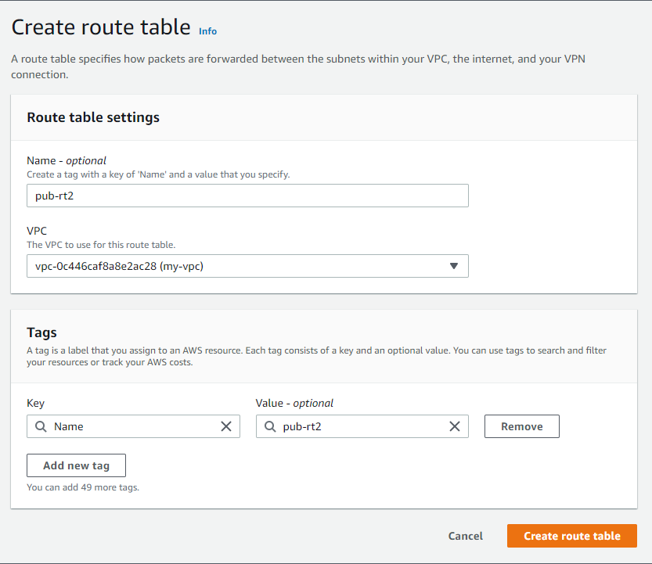

3.clikc on create route table

Step 5: Route table you can associate with subnets

Route table :

Note : One vpc always configuring one route table by default

You required two route tables

Default Route table consider as RT-1

Create route table 2 RT-2

Route table 1 associate with public subnet -1 Route table 2 associate with private subnet2

Which make it as public subnet attached to the route table that Route you can attach to the internet gateway

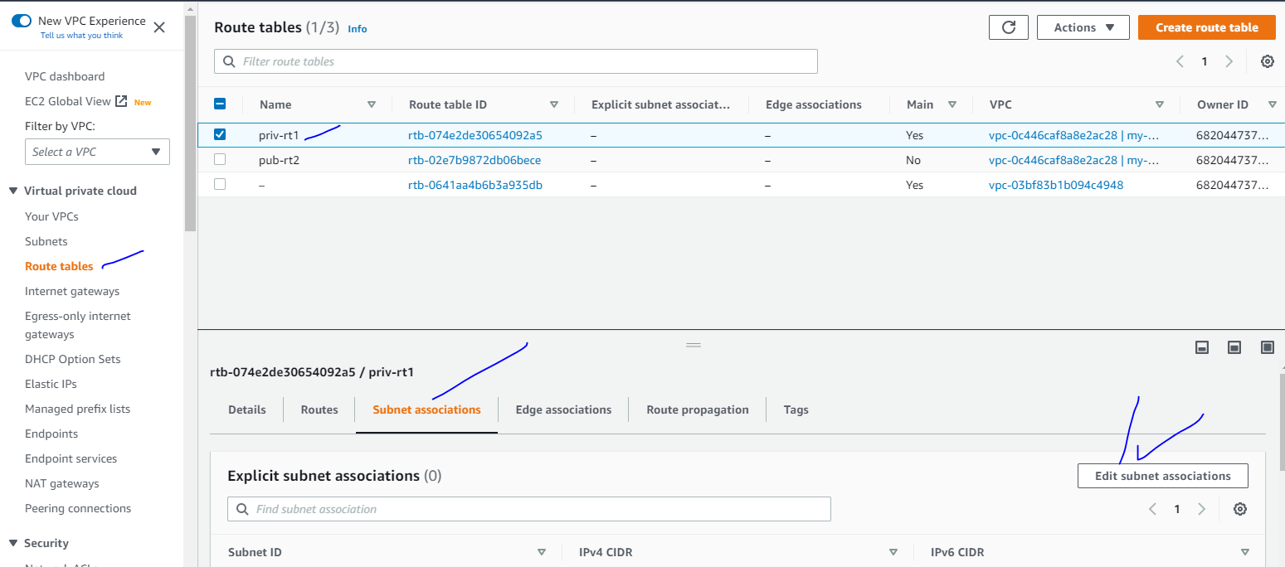

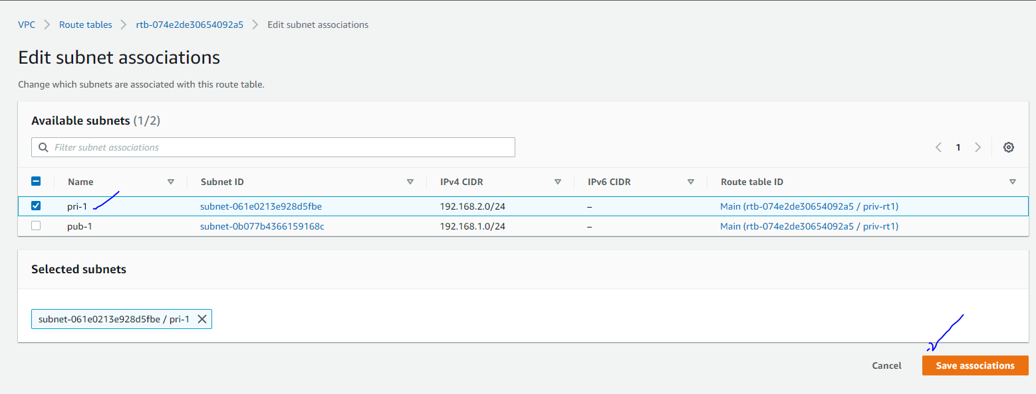

Step6: public routtable you can attach to the internet gate way

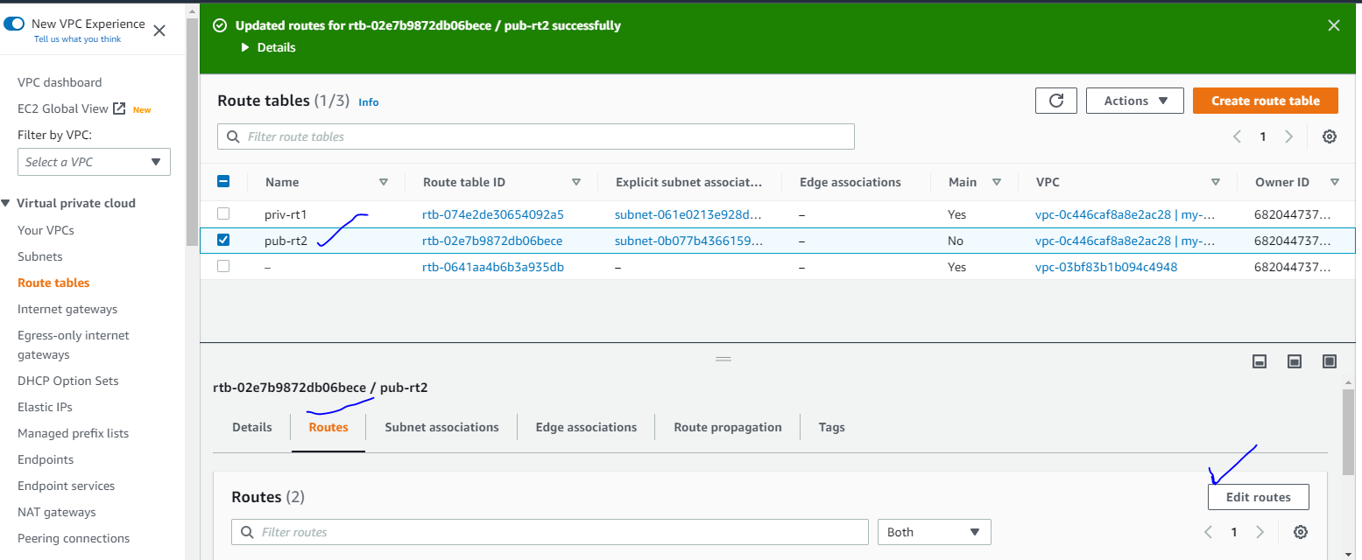

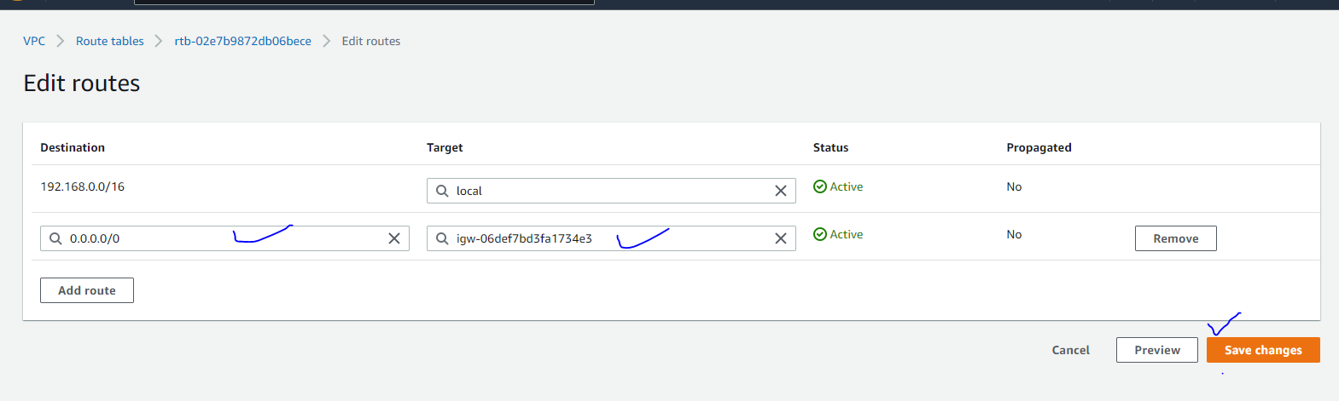

Enable the DNS HOSTNAME

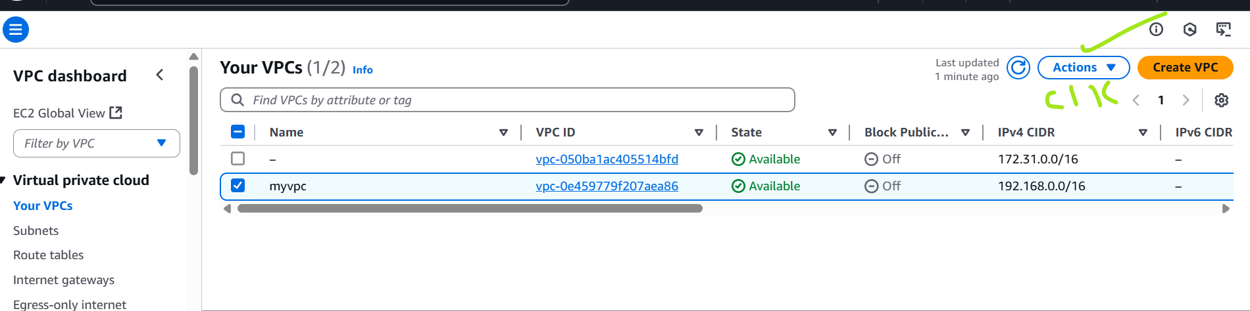

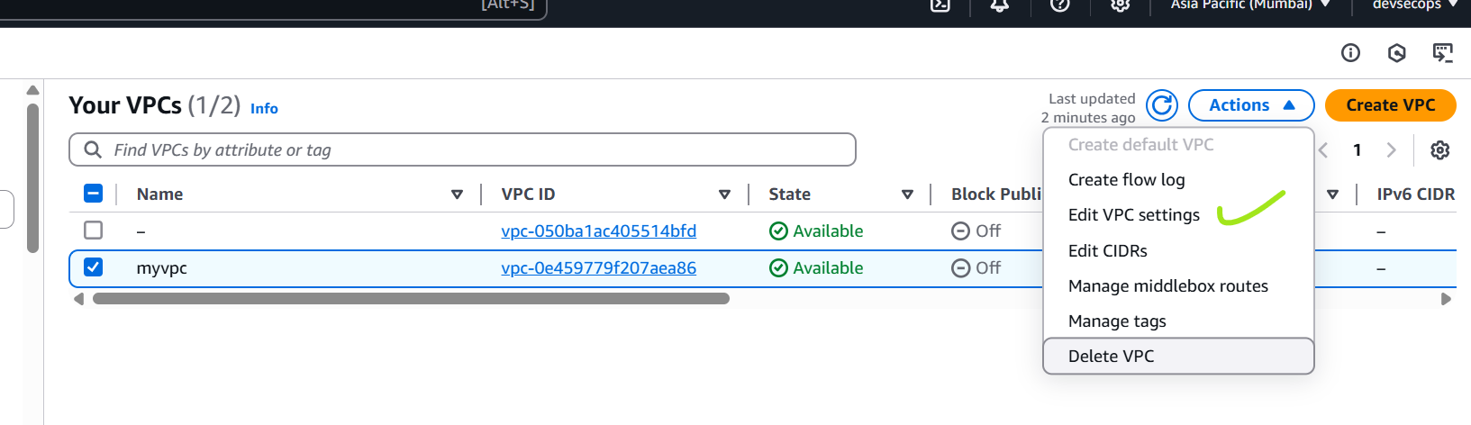

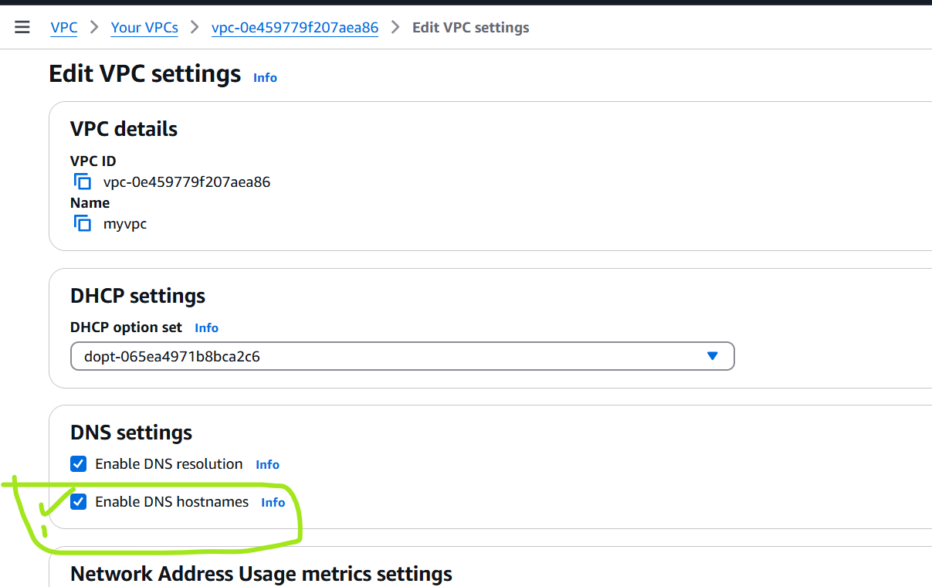

Check the check box

Click on save

Step7 :Create two ec2-instance

One instance public ->application

Second instance privte is public ip disable 🡪no internet ex: mysql

How do you connect private instance

Ping private ip 🡪to verify the coonnection

Copy the key and past it public instance in the server level

Change the permission of key file chmod 400 mumbaikey.pem

Run these command ssh -i mumbaikey.pem ec2-user@192.168.2.122

**Create a NAT Gateway :**

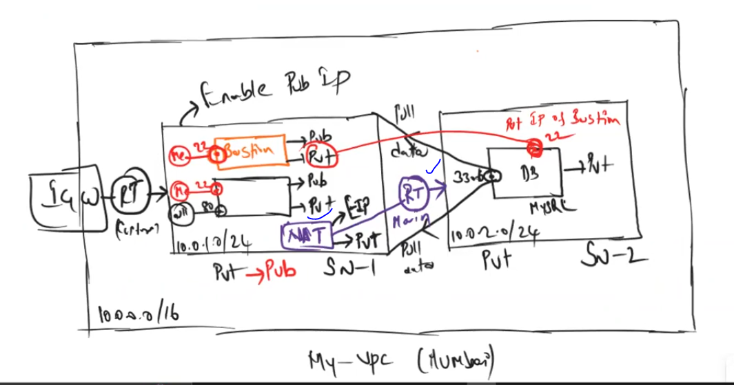

Nat gateway require elastic ip

Nat gate you can associate with the private subnet

How to create NAT gate way ?

Nat gateway require Elasticip

1. Go to aws dashboard
2. Search vpc 🡪click on vpc
3. Clik on Nat gate way

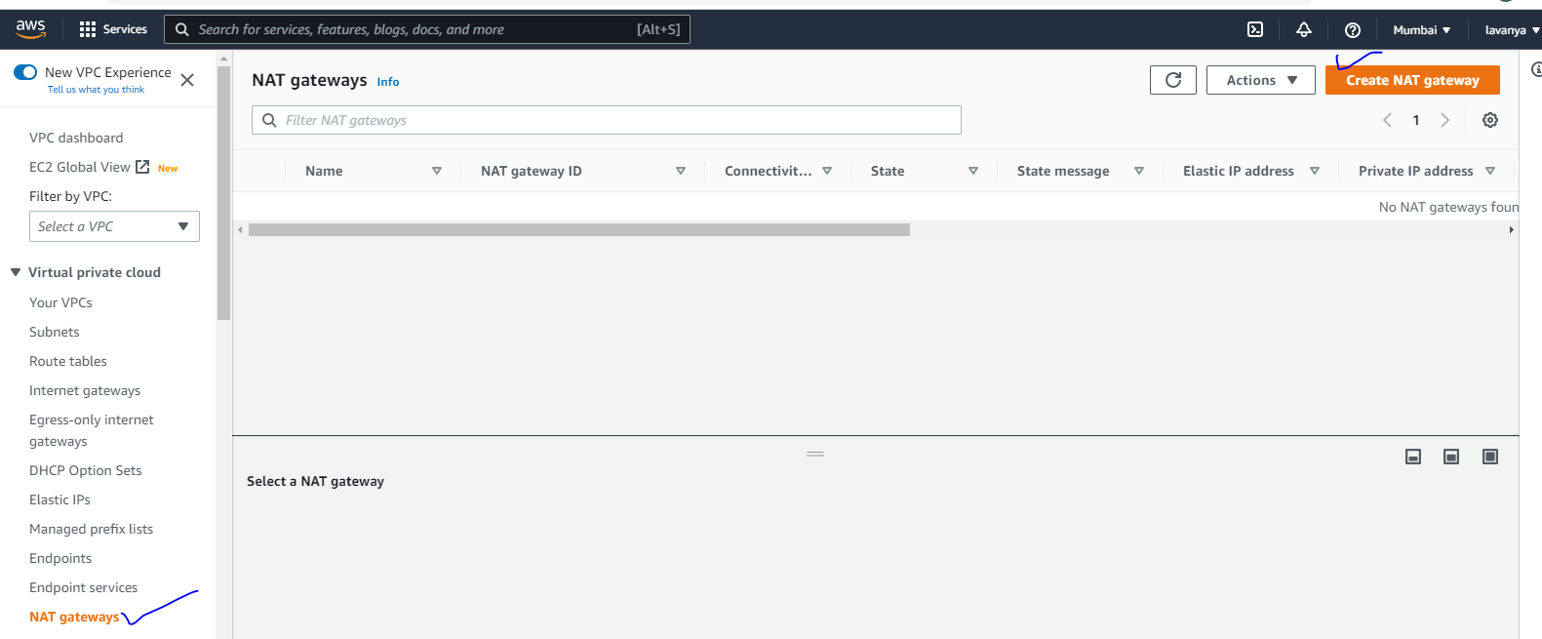

4.click on create nat gateway

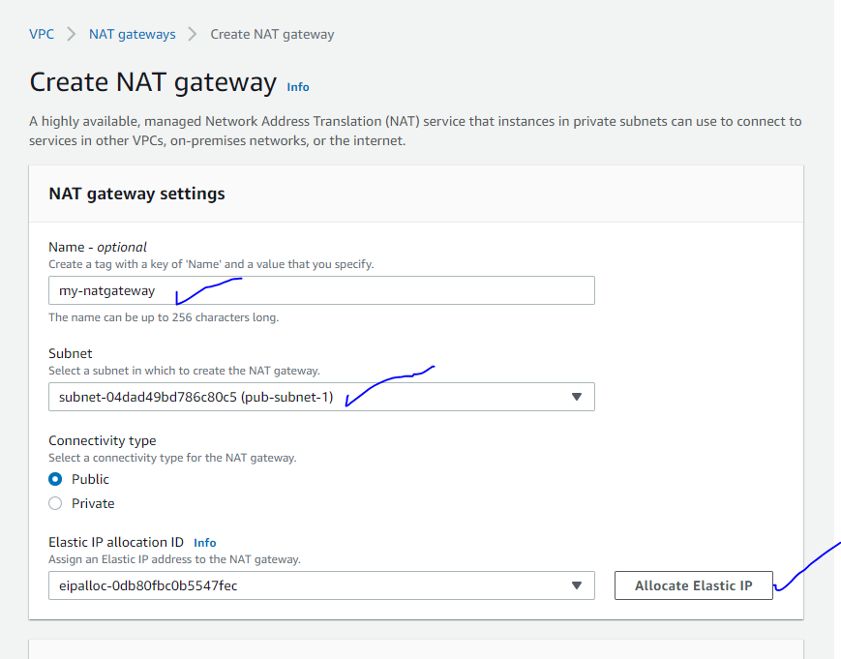

5.clikc onncreate nat gateway

Attach nat gate way to the private route table :

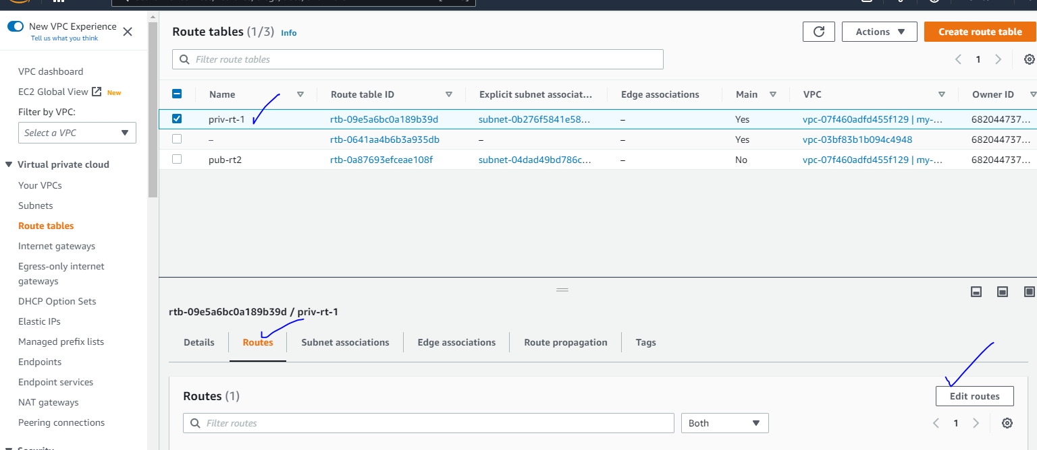

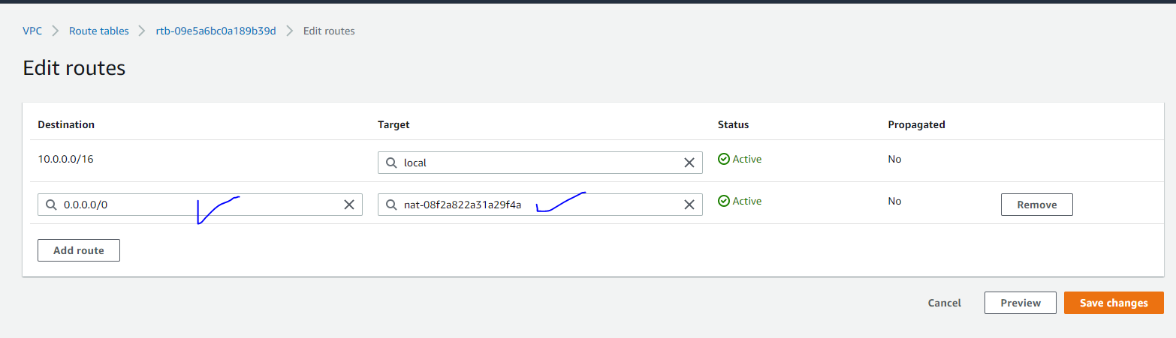

Vpc - NACL :

Along with vpc NACL is created

NACL attch to the subnets

Nacl deal with security at subnet level

How to create NACL ?

Install httpd in public ec2 instance

Vim /var/www/html/index.html

Hi sai how r u you 19 lacs package good 🡪 when you take public ip it’s working

1. Go to aws dashboard
2. Search vpc 🡪click on vpc
3. Clikc NACl under security

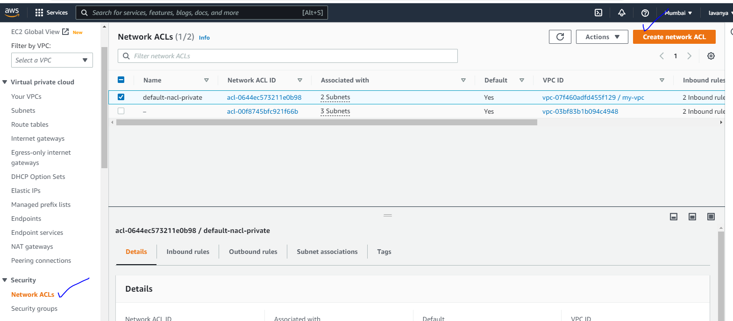

2.clikc on create nacl

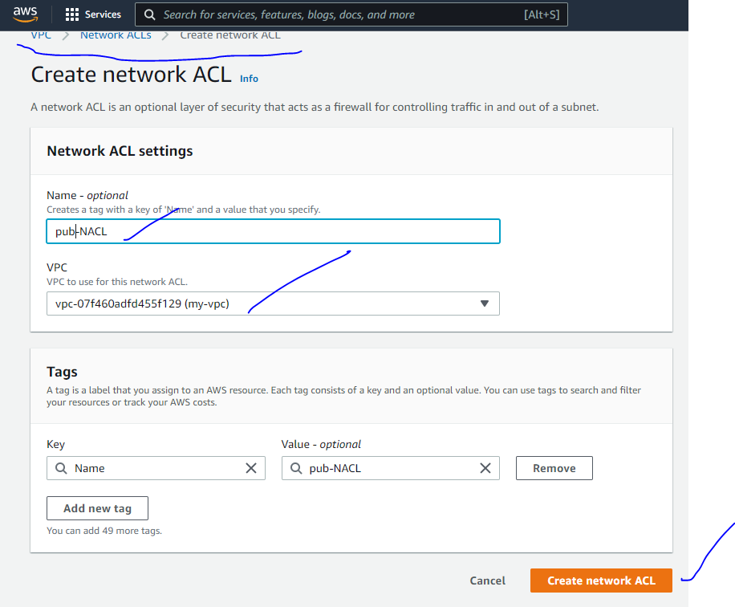

4.select public nacl and attach to the public subnet

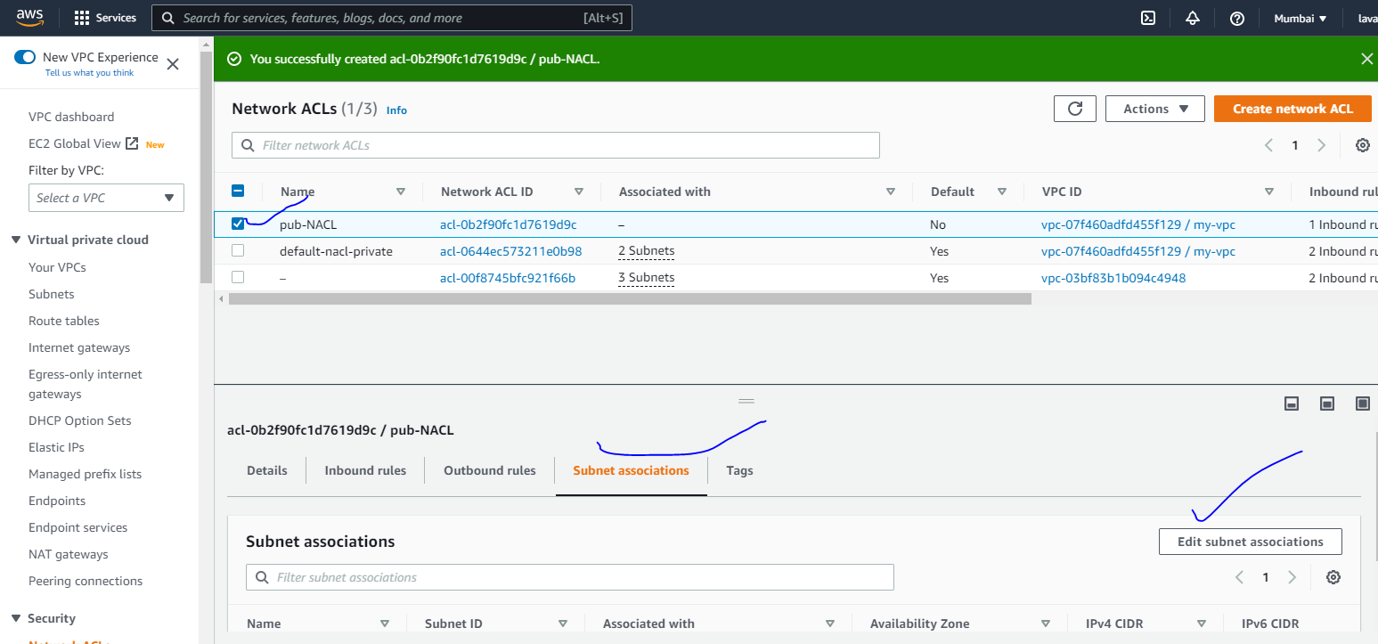

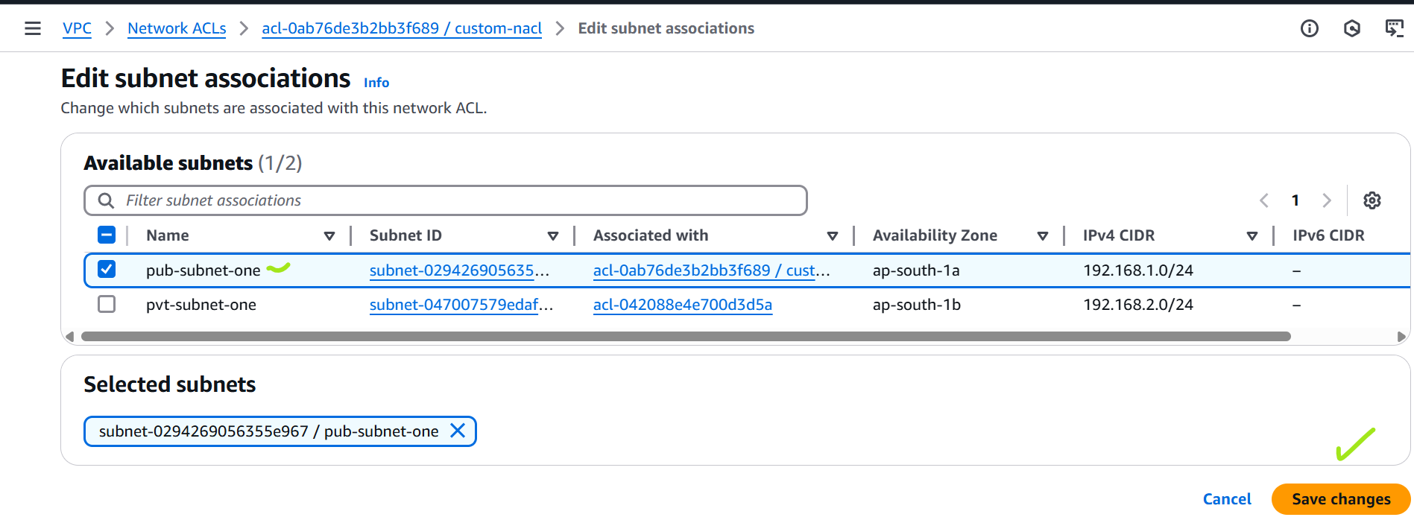

Click on save the change

Now it’s not working the website

Go to NACL

Click on nacl what you created

Click on inbound rules

Click on edit inbound rules

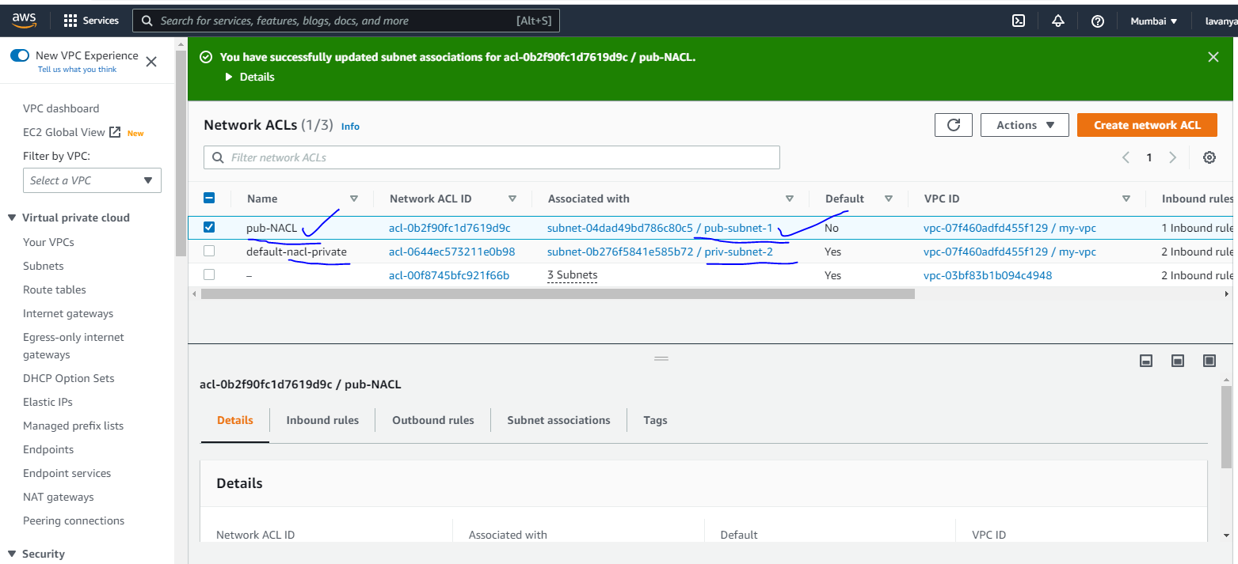

5.change inbound and outbound rules

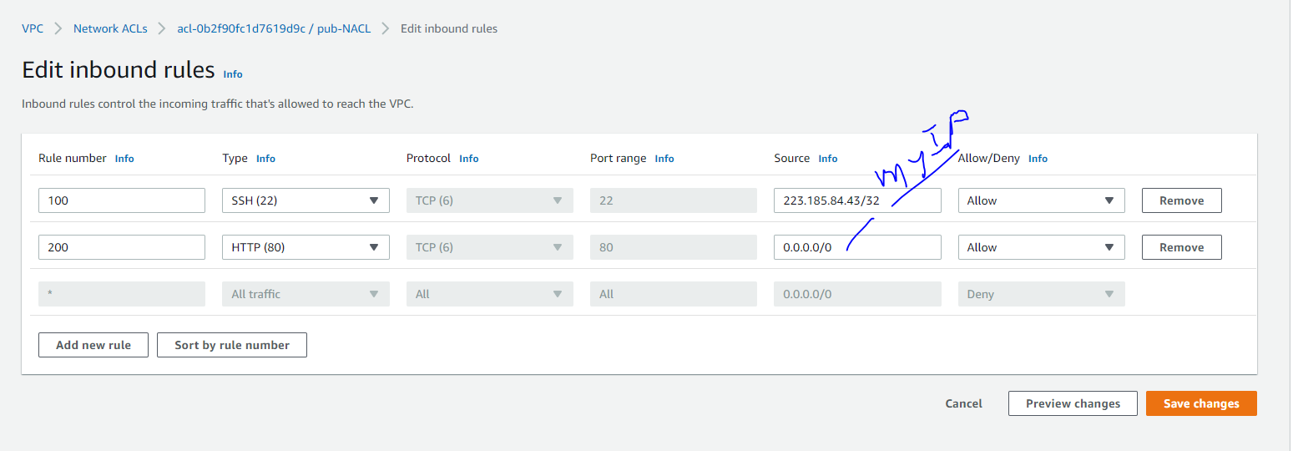

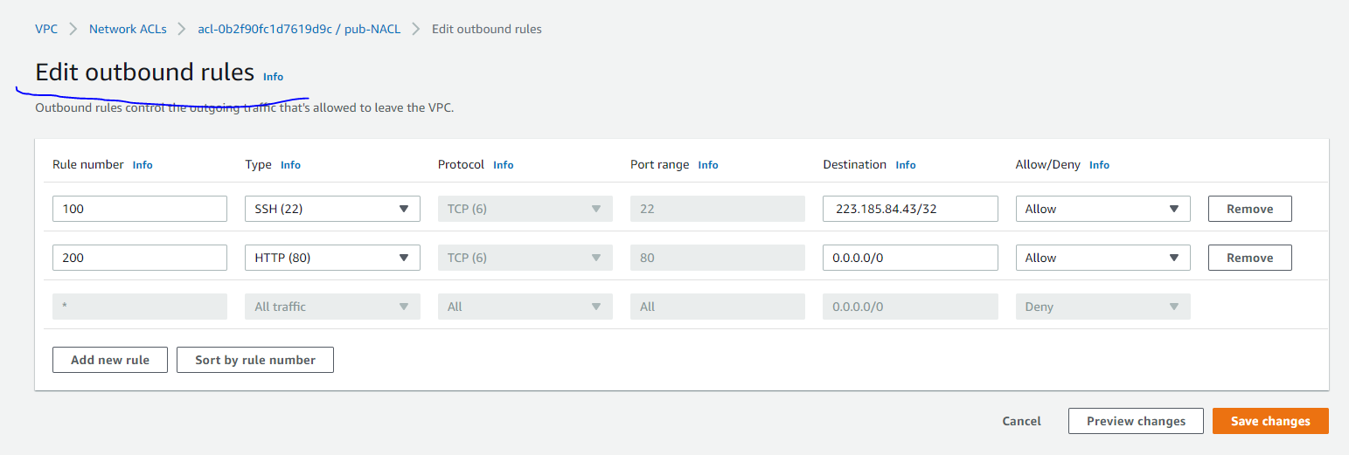

Inbound and outbund you can change

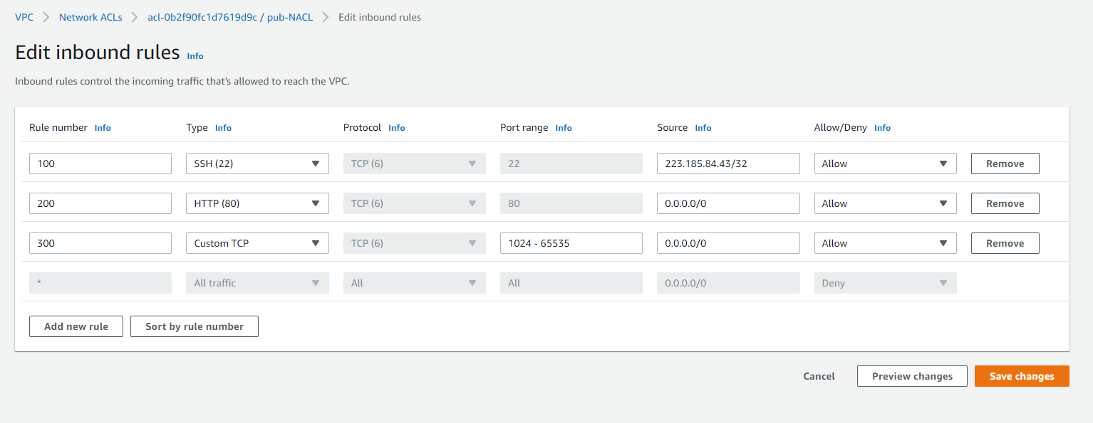

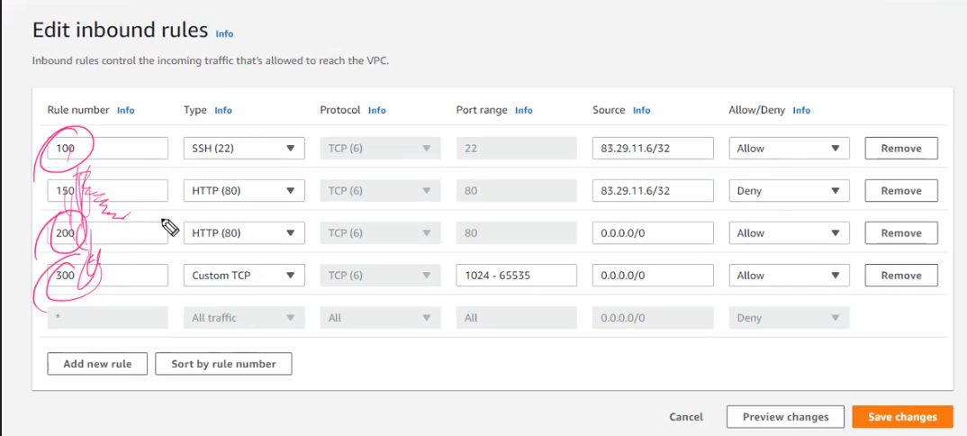

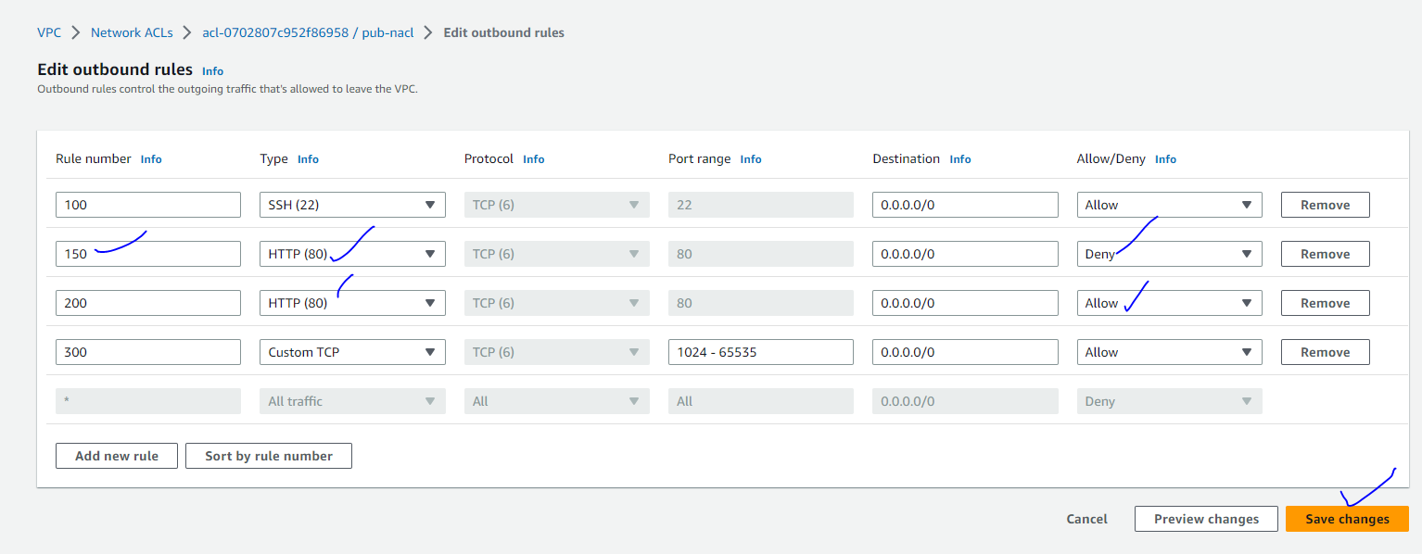

Now website is working fine

Deleting order vpc

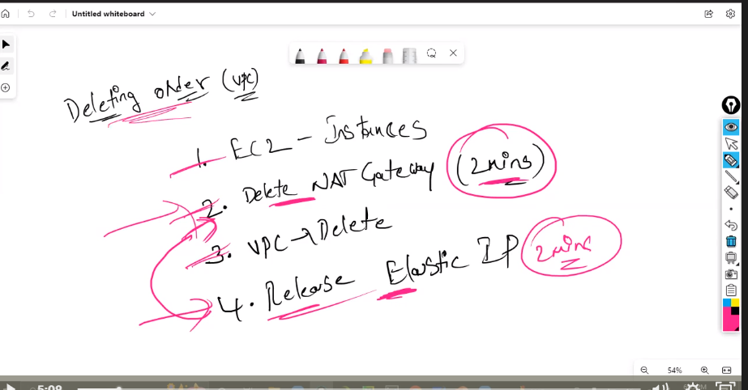

VPC Peering :

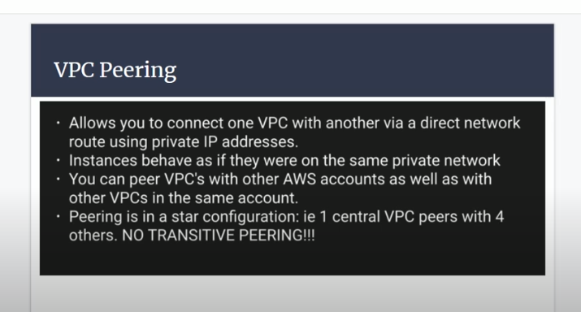

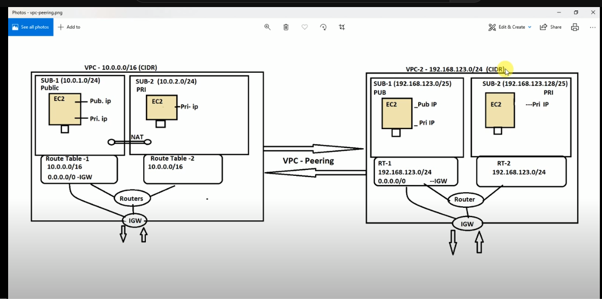

Create two vpc

Subnets

Route tables

Igw

Attach RT to subnets

Attach pub-RT to igw

Two VPC

Name :vpc-10

Name: VPC-192

Create vm in vpc-10

Public subnet vm

Create vm in vpc-192

Public subnet vm

One vpc network details :

Vpc creations 192.168.0.0/16

Two subnets

One subnet will be associate with one availability zone . one availbilty zone can associated with multiple subnets

Public Subnet 1 : 192.168.1.0/24 ap-south-1a(Mumbai) private subnet 2 : 192.168.2.0/24 ap-south-1b

When create subnet bothe subnets are private ..You make it has a public

Internet gate way

**Every vcp required internet gateway .every vpc have one internet gateway and attach to the vpc**

Route table :

Note : One vpc always configuring one route table by default

Second vpc

Vpc creations 10.0.0.0/16

Two subnets

One subnet will be associate with one availability zone . one availbilty zone can associated with multiple subnets

Public Subnet 1 : 10.0.1.0/24 ap-south-1a(Mumbai) private subnet 2 : 10.0.2.0/24 ap-south-1b

When create subnet bothe subnets are private ..You make it has a public

Internet gate way

**Every vcp required internet gateway .every vpc have one internet gateway and attach to the vpc**

Route table :

Note : One vpc always configuring one route table by default

Connect both machines

Ping vpc-192 machine

Ping vpc-10 machine

**It will not ping …why bothe are two different vpc

Vpc-peering

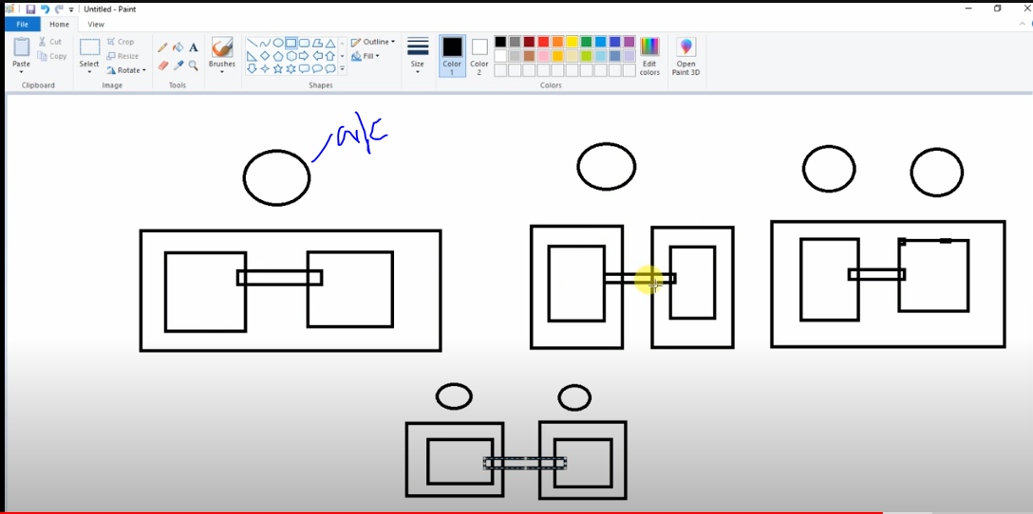

Create a peering steps :

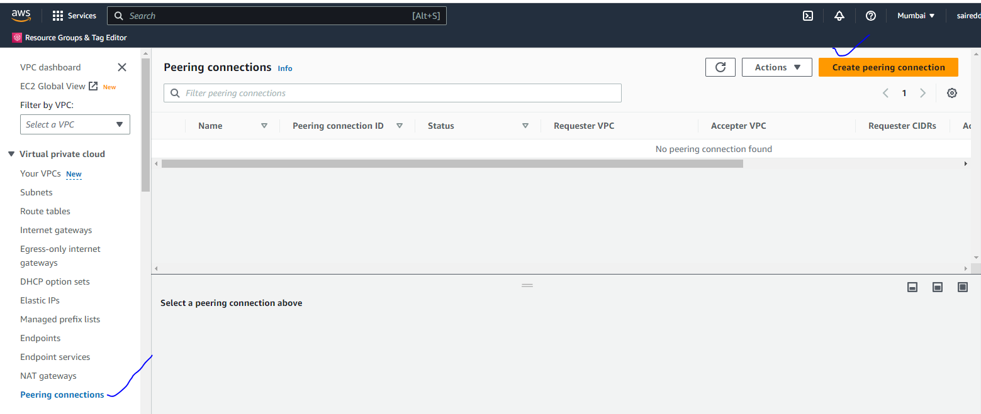

Click on create peering

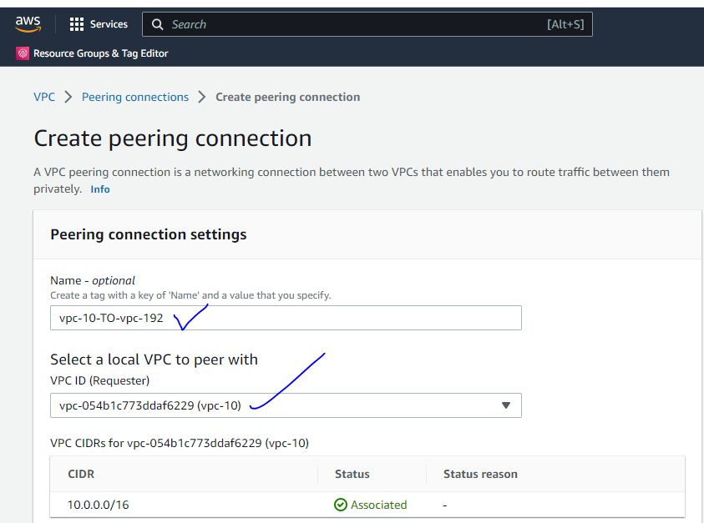

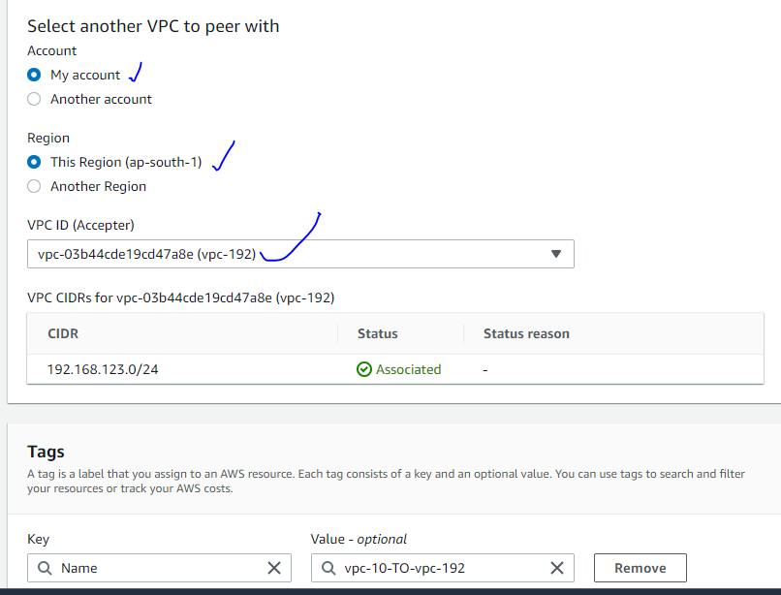

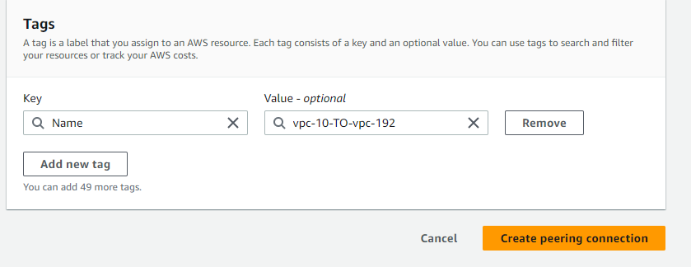

Click on Create peering

It will pending state you can accept the request

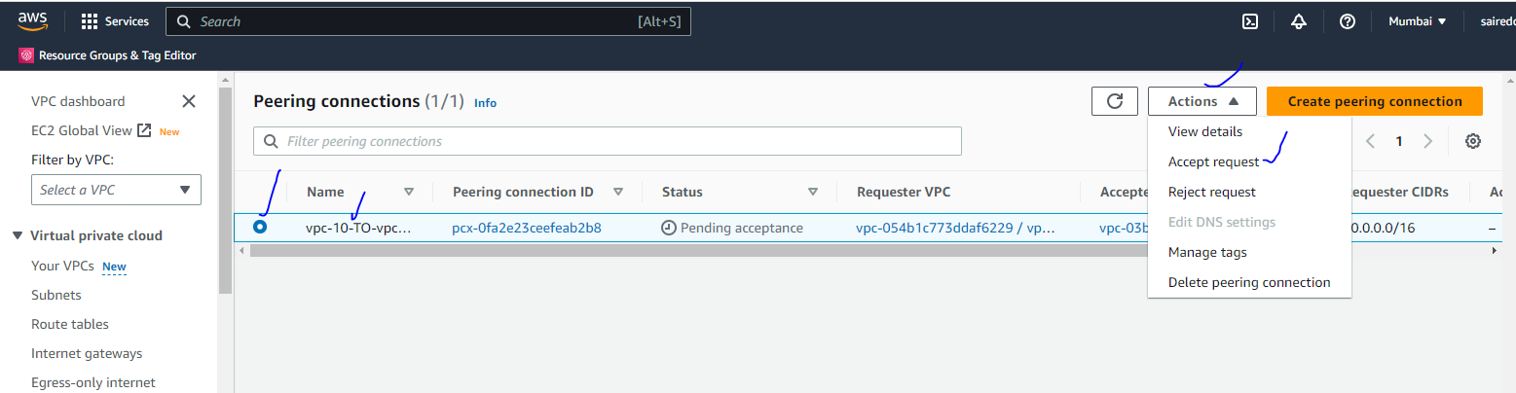

Click on accept the request

It will be active

go to Route tables

Click on routes

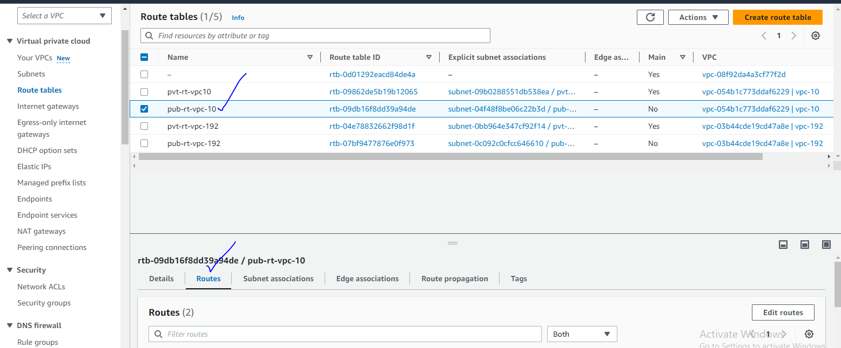

Click on Edit routes

10 to 192 peering the routes

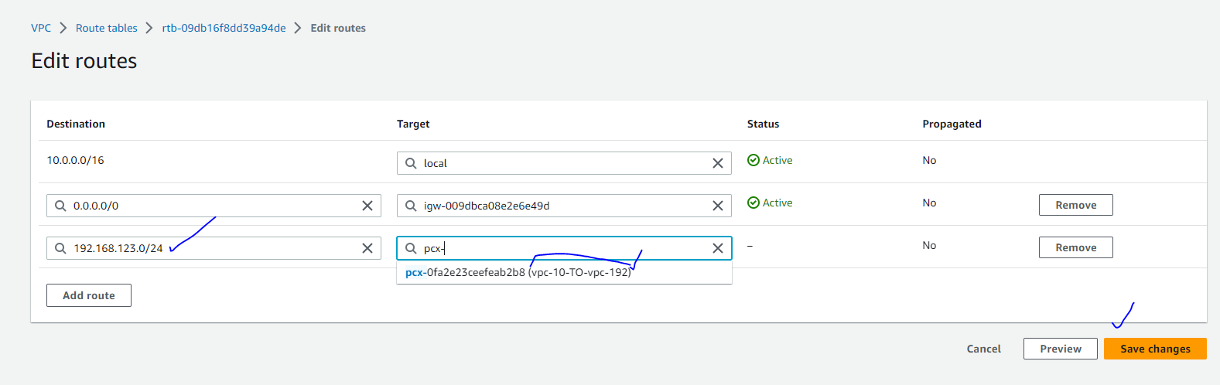

192.168 to 10 peering the routes

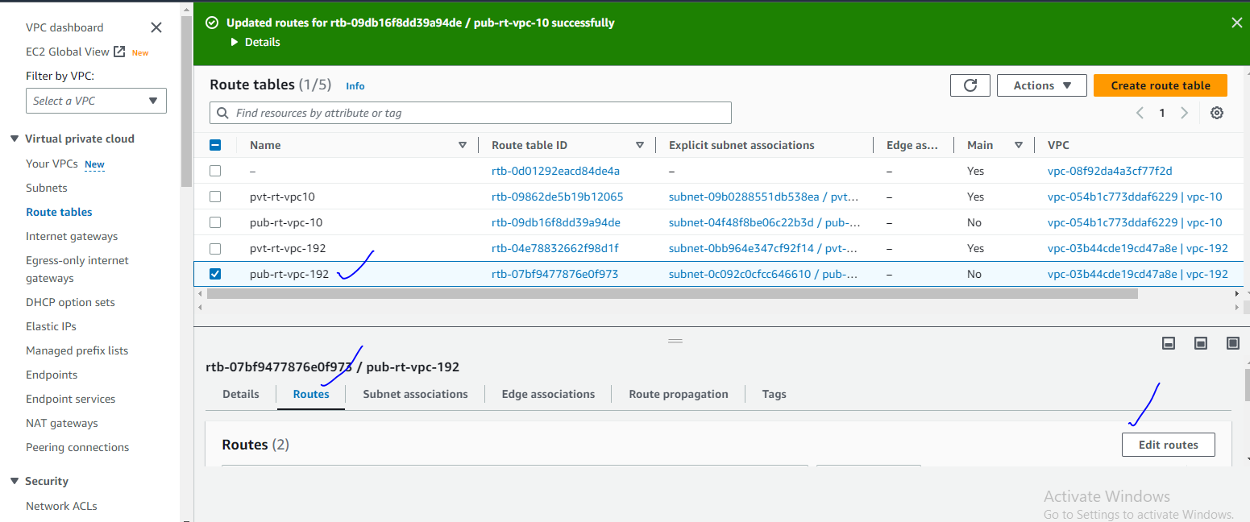

Click on Edit the routes

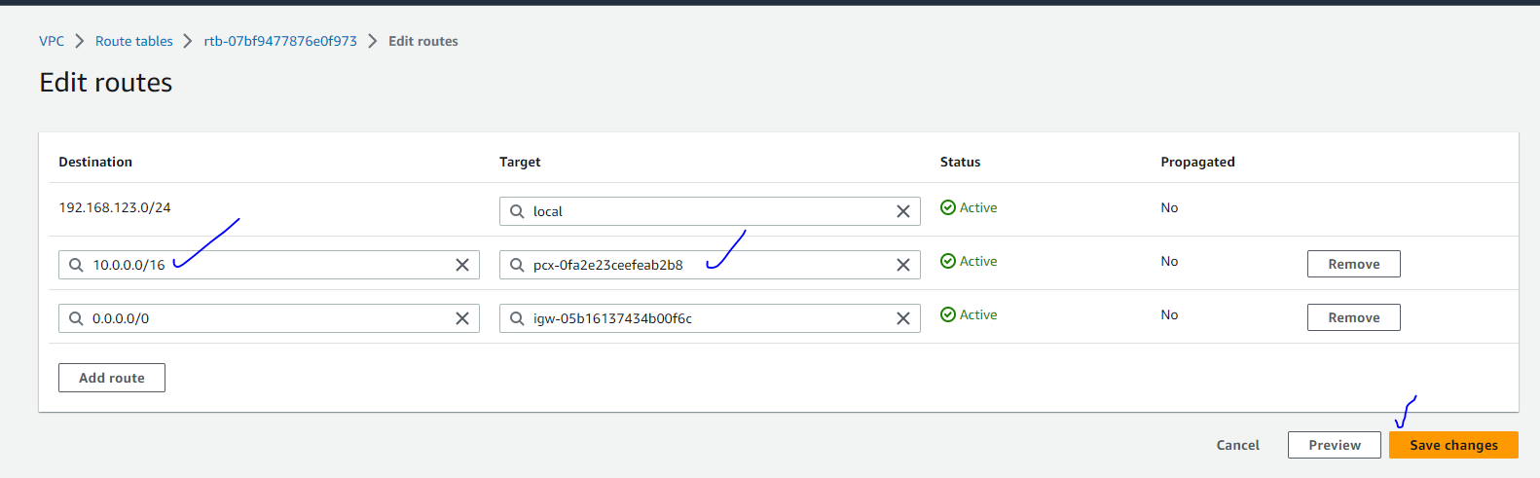

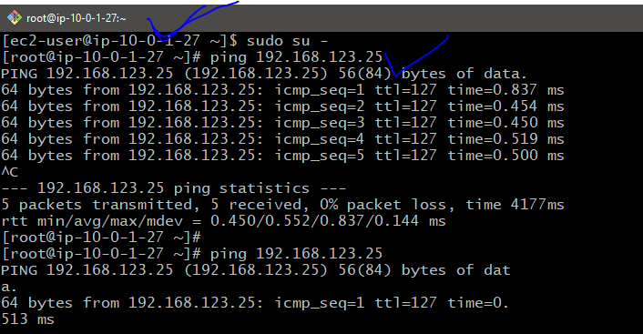

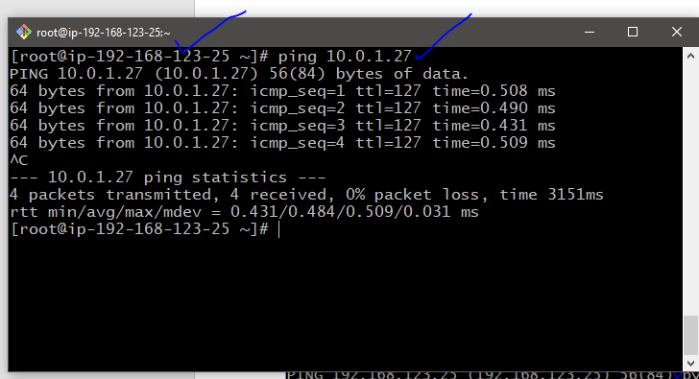

NO TRANSITIVE PEERING :

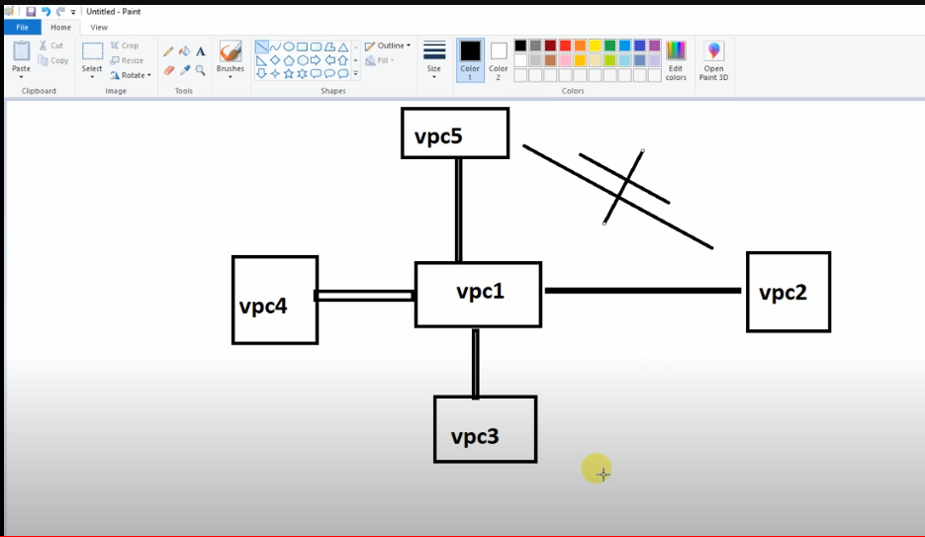

Vpc Endpoint :

VPC Endpoint :

1.Create a vpc

2.Create two subnets

3.Create IGW attach to your vpc

4.along with vpc one route table is created ..Create another route table

5.Route table associate with pub and pvt Subnets

6. pub route table attach to the IGW

7.pub-subnet assing the auto assign public ip

Create two aws ec2 instance

1 for pub-ec2 instance

2. for pvt ec2- instance

**Go to IAM**

Create a user ex: testuser

Provide s3 full accesss

Go to instance

Aws configure

Enter access key and secret key and region and text or json

Aws s3 ls

Pub-ec2 instance aws s3 ls command works

Pvt ec2 instacne aws s3 ls command not works

Create VPC Endpoint :

With out having internet connectivity you can access aws resouces using VPC end point .

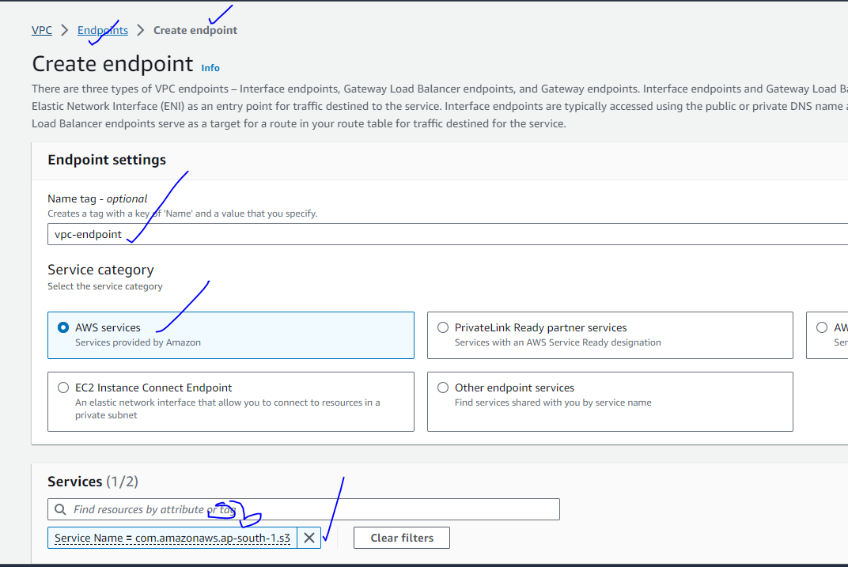

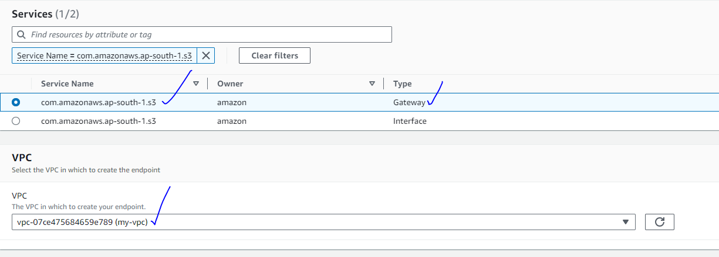

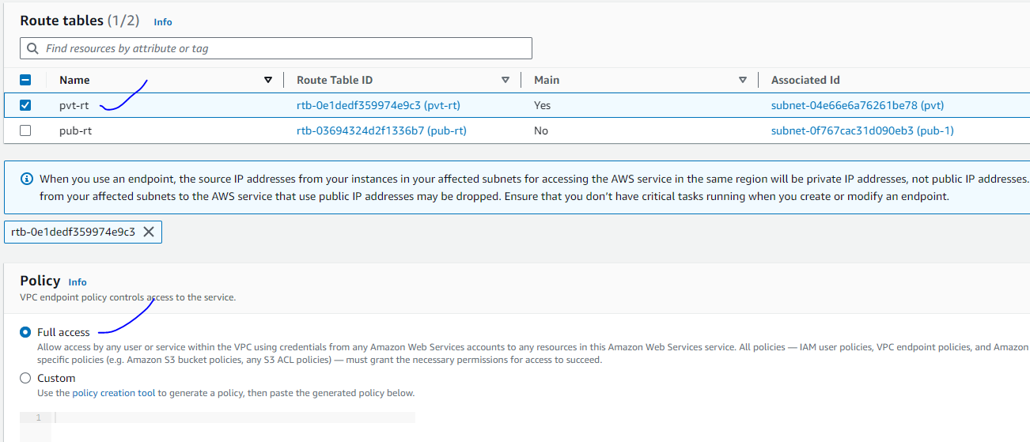

Without having internet access you can access aws resource or service using vpc endpoint

VPC Flowlogs :

You want to monitor the traffic ,you can be enable to logging

You can monitor vpc level and subnet level also

Create a custom policy in IAM :

1. Go to iam
2. Click on create policy
3. 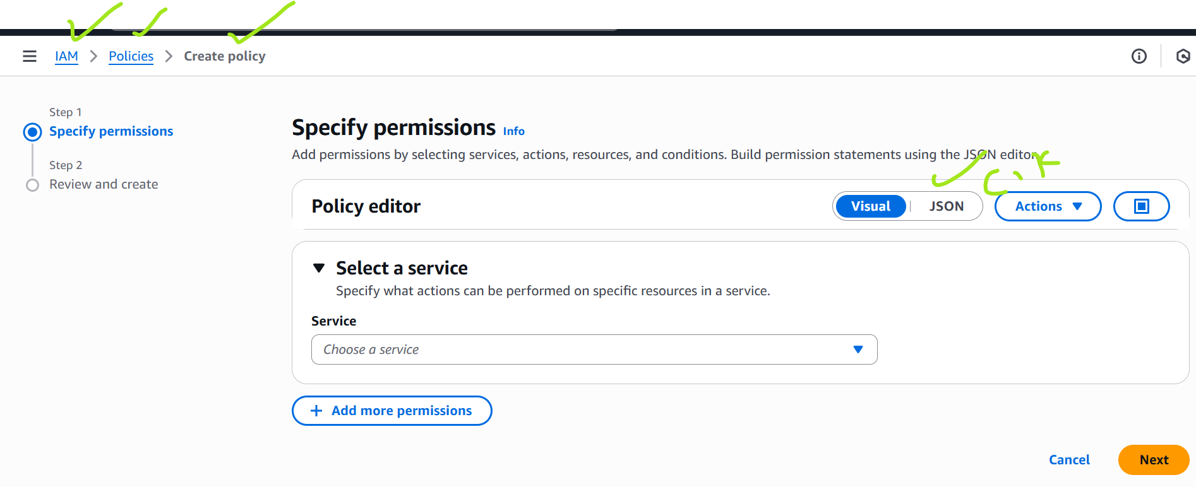

{

  "Version": "2012-10-17",

  "Statement": [

    {

      "Sid": "VisualEditor0",

      "Effect": "Allow",

      "Action": [

        "logs:CreateLogStream",

        "logs:DescribeLogGroups",

        "logs:DescribeLogStreams",

        "logs:CreateLogGroup",

        "logs:PutLogEvents"

      ],

      "Resource": "*"

    }

  ]

}

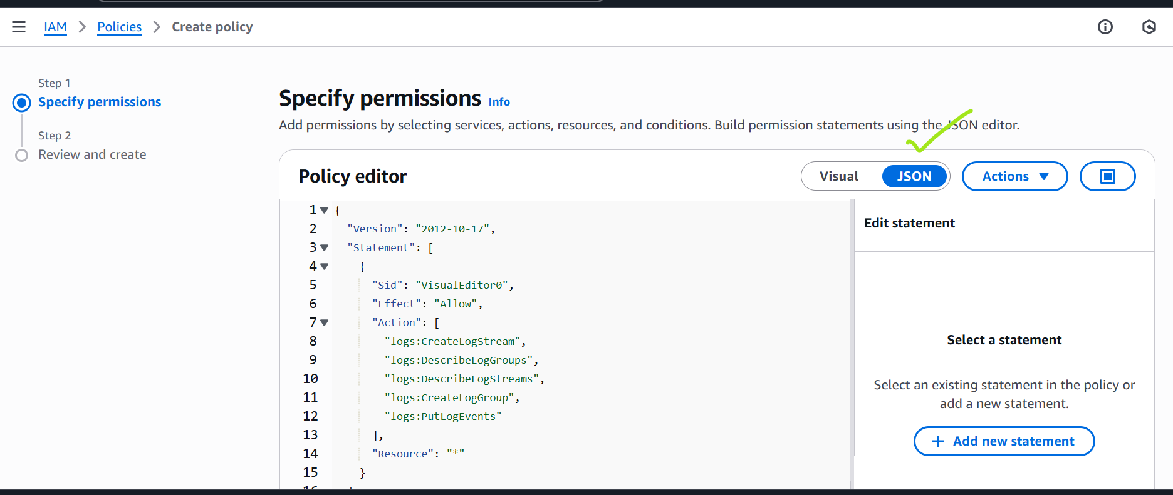

Click add the json

Add above file

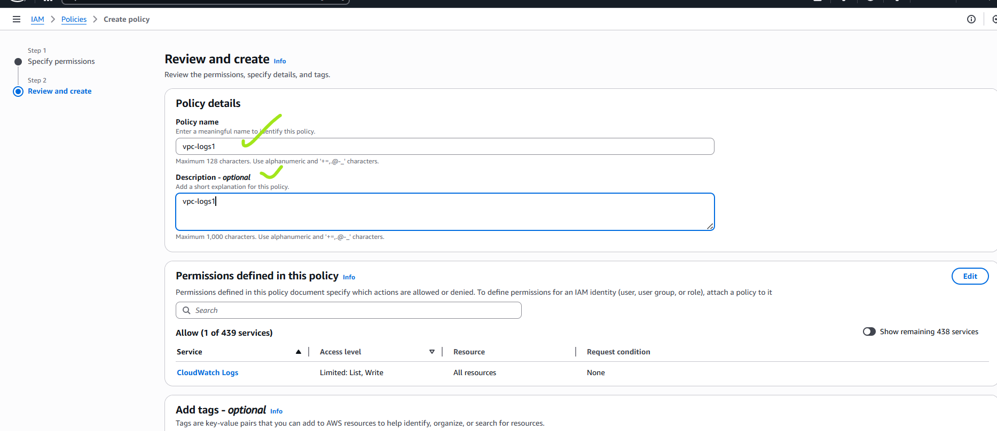

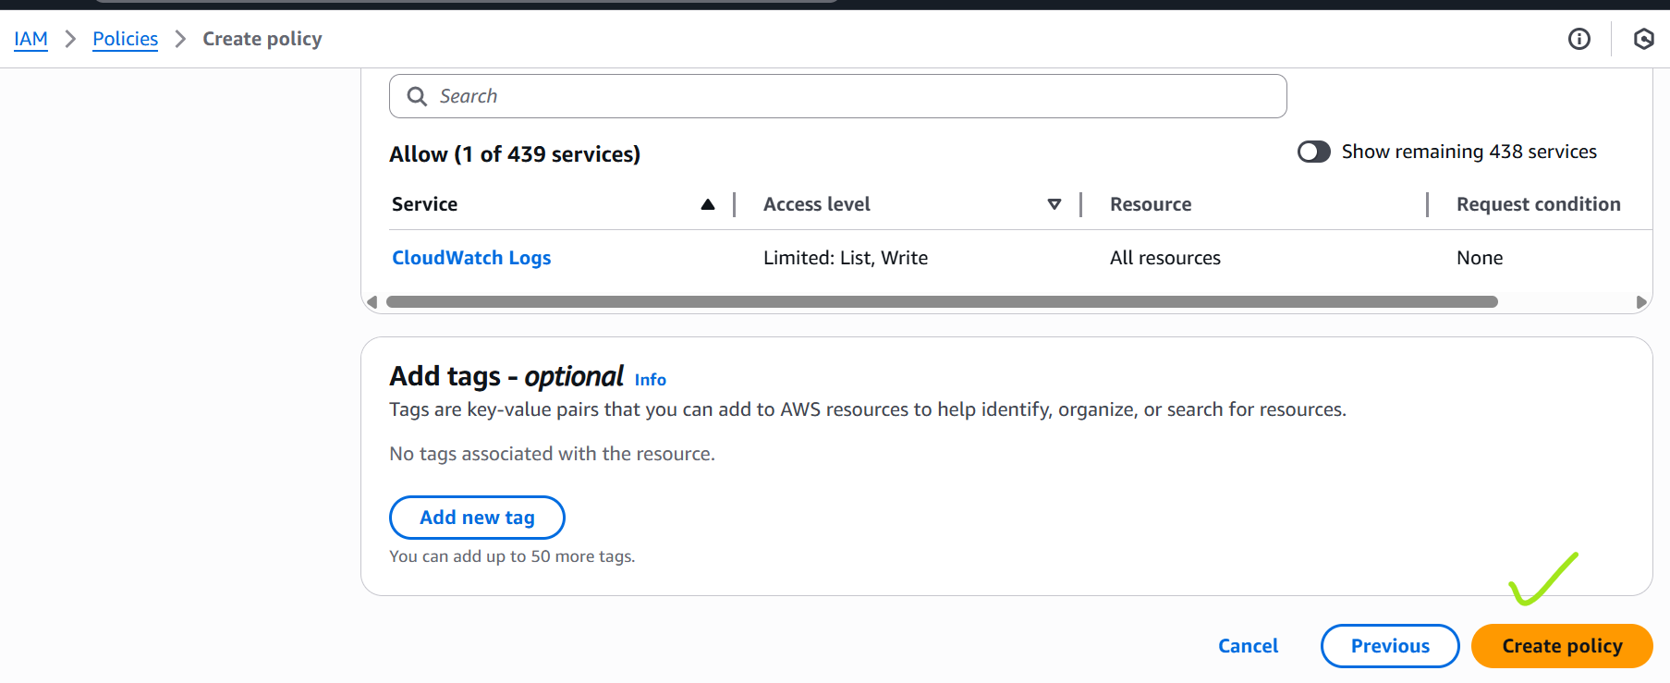

Click on create policy

Step2 :Create a role

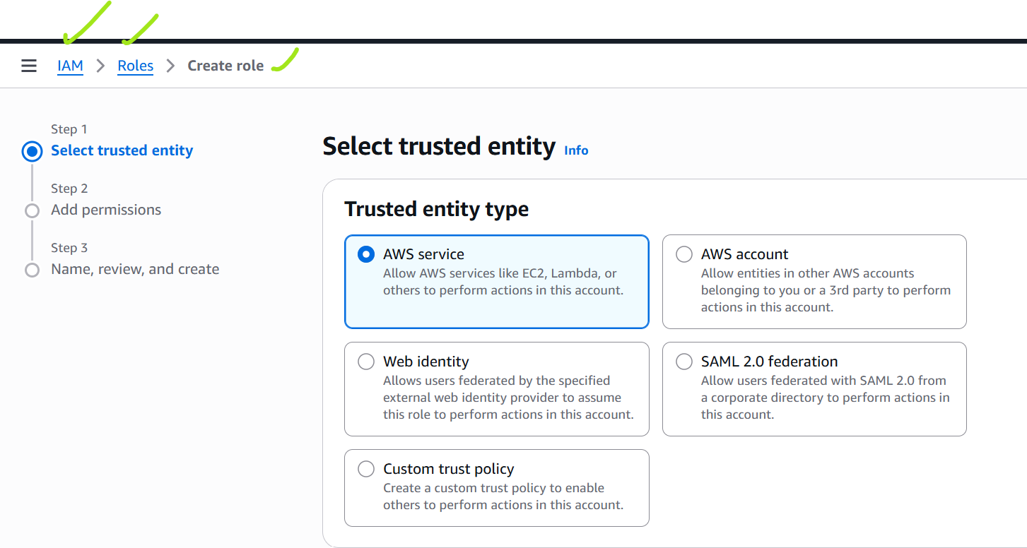

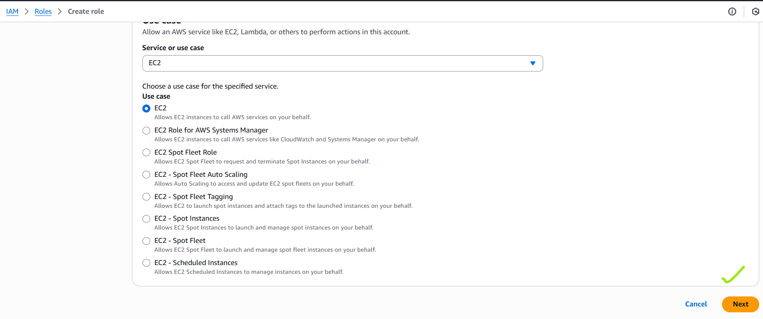

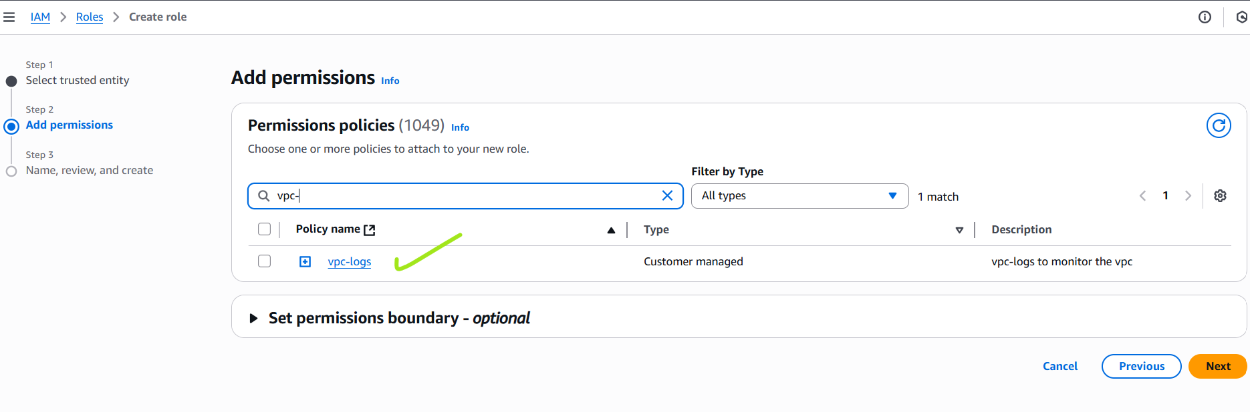

Search custom policy step 1 as you created custom policy

Search it and Select it

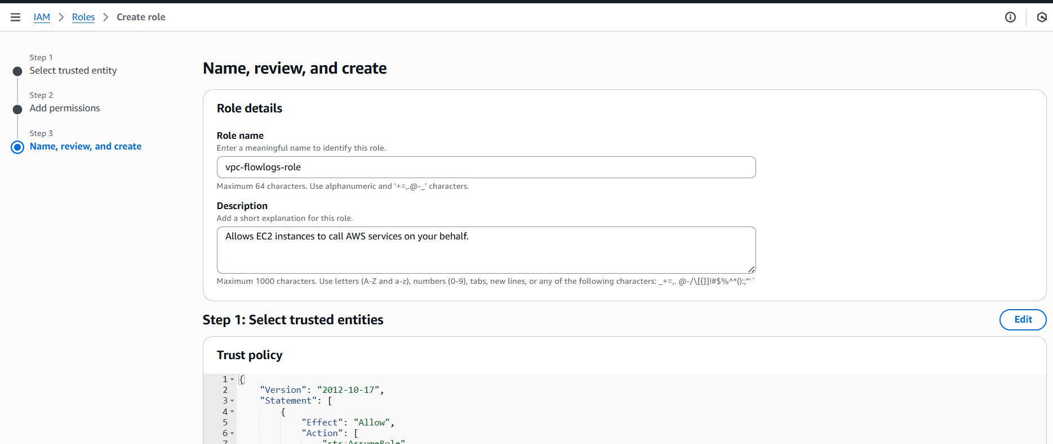

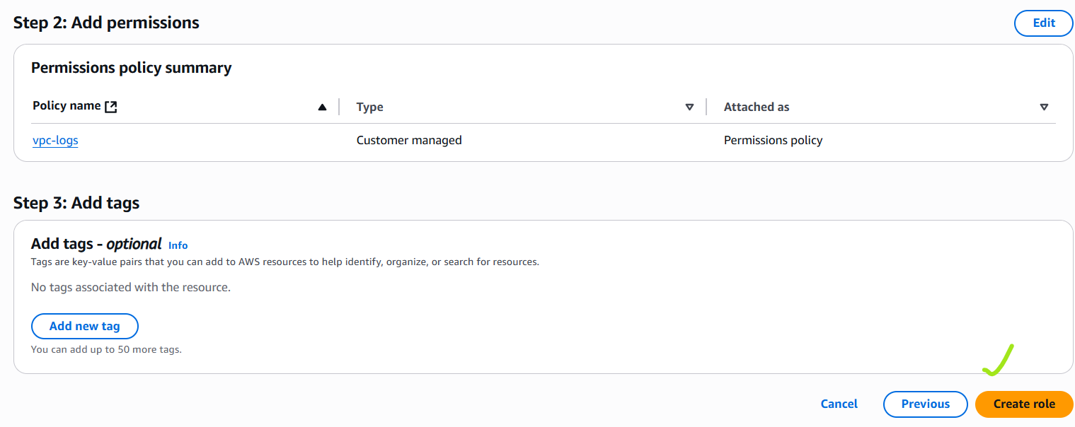

Role is created successfully

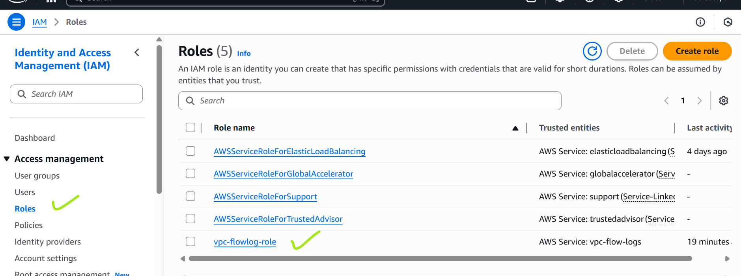

Role is created successfully

Click on vpc-flowlog-role

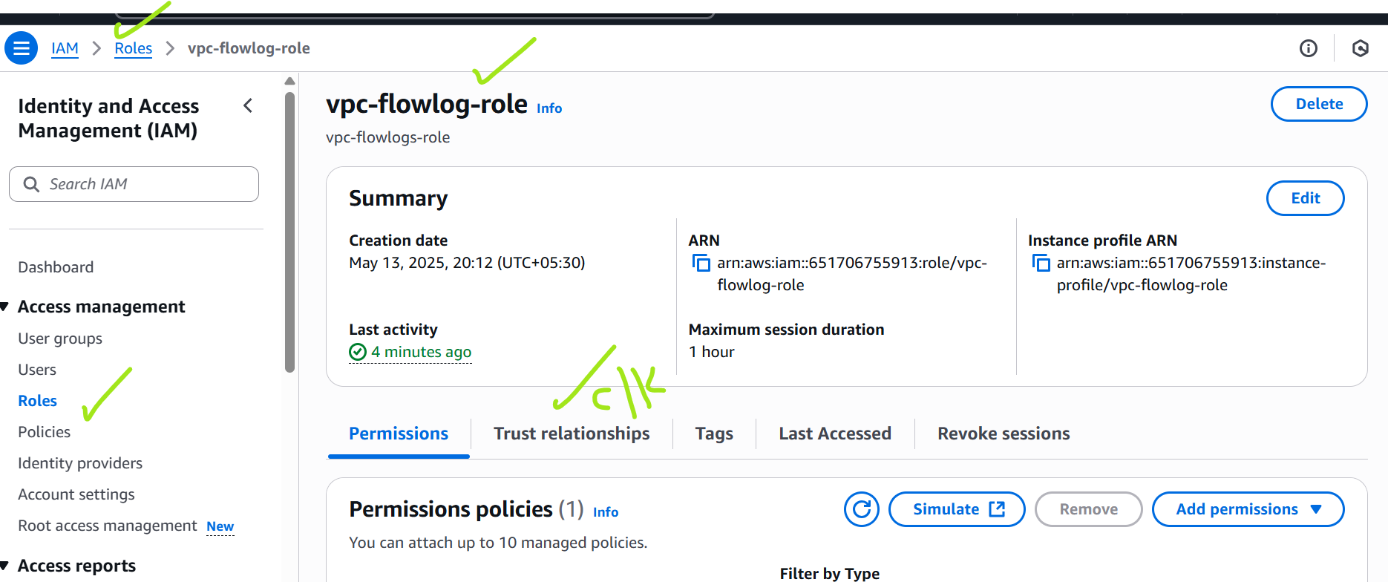

{

    "Version": "2012-10-17",

    "Statement": [

        {

            "Effect": "Allow",

            "Principal": {

                "Service": "vpc-flow-logs.amazonaws.com"

            },

            "Action": "sts:AssumeRole"

        }

    ]

}

Add these

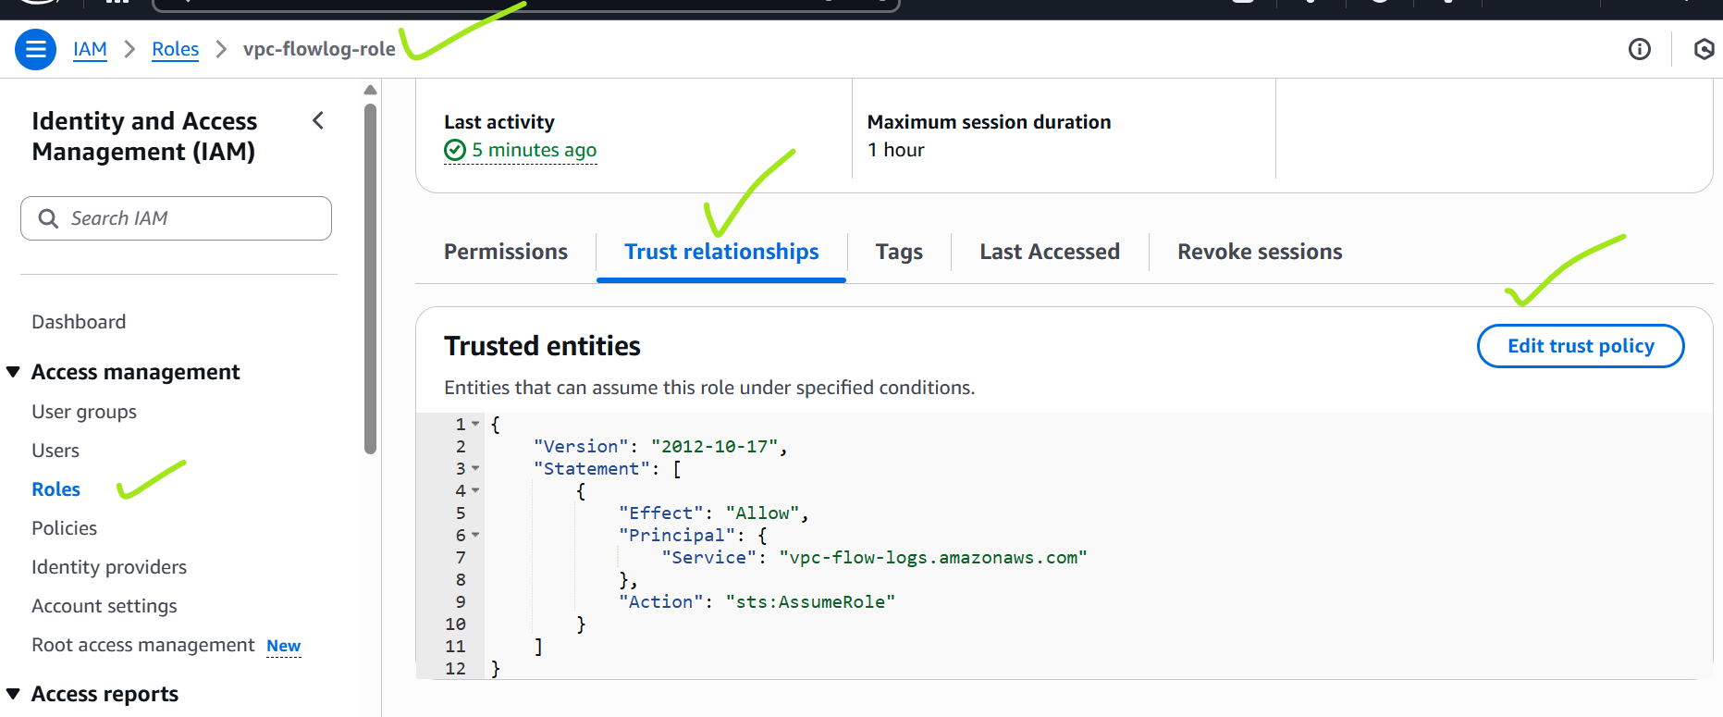

Add it .

Click on update policy

Step4: Create cloud watch logs group

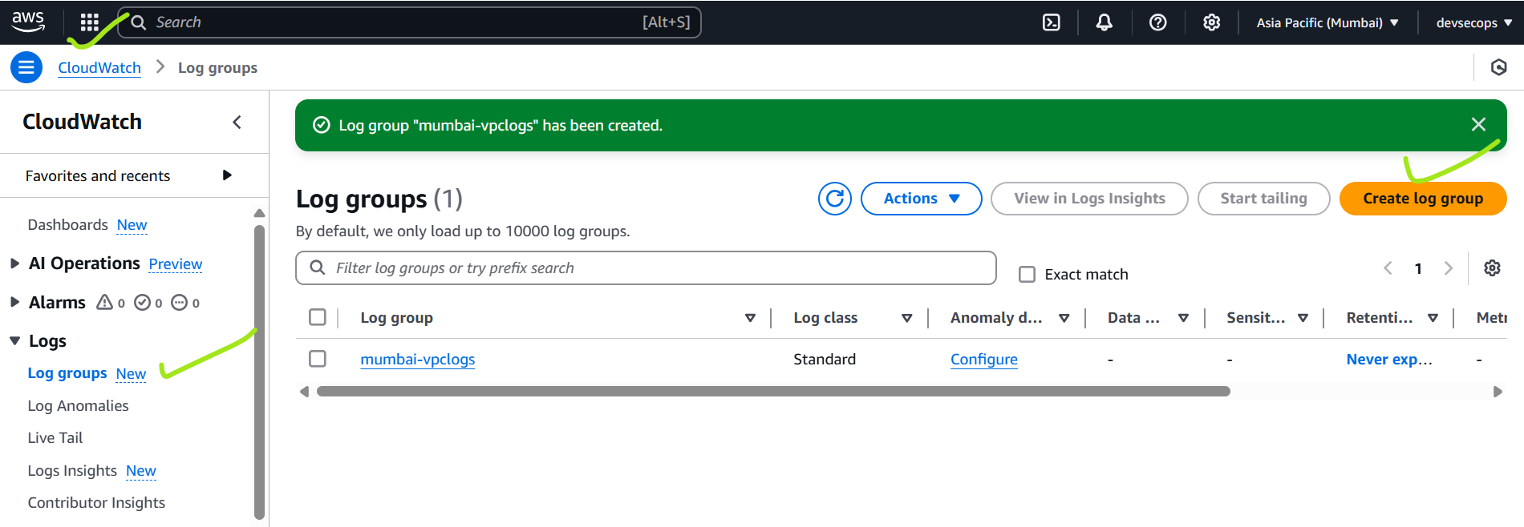

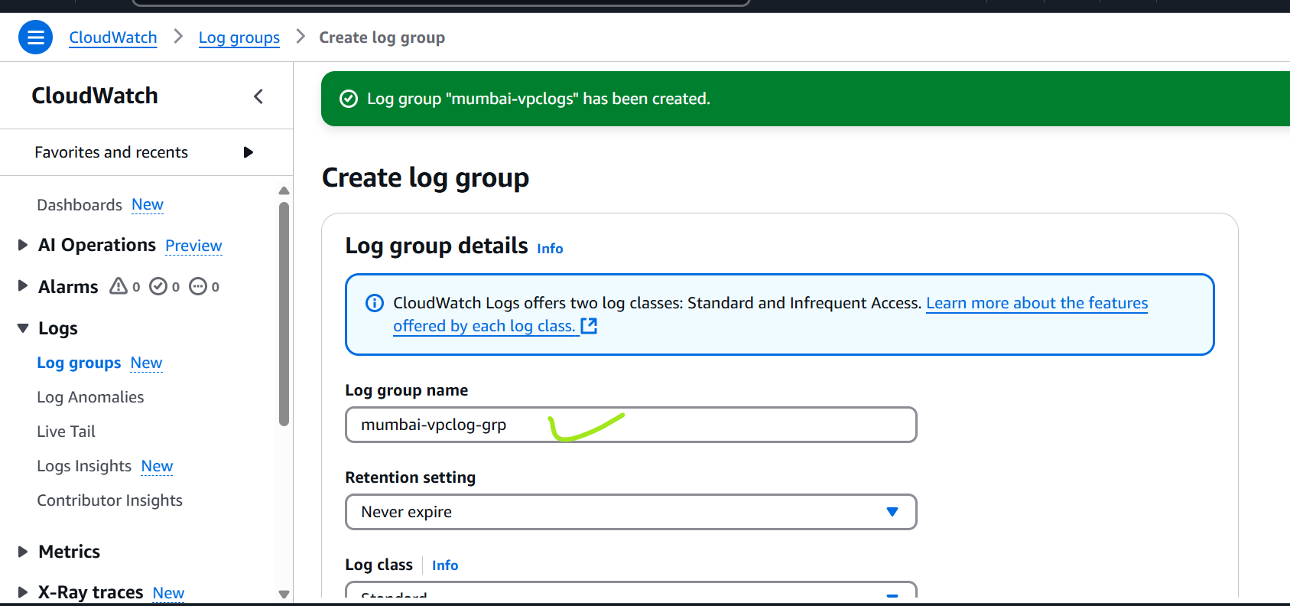

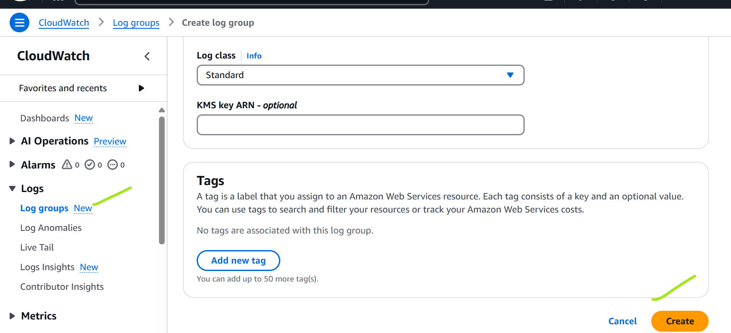

Click on create

Step 4: go to vpc

Click on vpc

